

Data Story Telling

Assignment 1

Parisa Azimviahdat | Data Skills | 19-02-2023

Table of Contents

Cover Page**0**

Table of Contents1

Main Body2-34

A Reflective34-35

**Assignment 1 Data Story Telling**

Scenario2

First Task

Policies and Procedures3

Second Task

Excel4

Third Task

Tableau27

Scenario

Data Access authorization and control are vital parts of an organisation's sensitive data protection plan. Various contingency plans are designed to counteract accidents, breaches or the impact of data management. The following are considered when planning:

1. GDPR compliancy and checklist.
2. Access policy deciding those authorized to access and control the access to data by job role, responsibility, and duration.
3. Consistency in secure ways to back up the data.
4. Updating and securing the software, data storage and data in transmission.

[Your GDPR Compliance Checklist](https://assets.website-files.com/60b6a4471d974075c999d1fb/6172babe130caeacc6065b8e_Vanta_GDPR_Checklist.pdf)

Employee, user and guest policies regulate users’ proceedings to ensure intruders are kept out of the data system. These policies are designed to restrict and control users’ access to sensitive data.

1. Encryption Policies
2. Acceptable Use Policy
3. Password Policy
4. Email Policy
5. Data Processing policy

[IT Governance](https://www.itgovernance.co.uk/blog/5-data-protection-policies-your-organisation-must-have)

Organisations will also upkeep various contingency plans to counteract accidents and the extent and impact of their data use.

Task 1 – Policies and Procedures

As a learner at JUSTIT, I am an accountholder with privileges to access SharePoint, sharing permissions and access to Microsoft 365 and applications included in the membership package. The security concerns are handled by Microsoft who is the service provider managing a SaaS-platform for software services. All data is protected thereby by the organization, JUSTIT, the data controller DfE, Department of Education and the Service provider, Microsoft.

As a user I have access to ‘Wealth of the Nations’ and can download a copy from the link below without obtaining permissions:

<https://justit831.sharepoint.com/:x:/s/DataAnalyticsProgramme-NewStandards/EVK1dsCfWvZMpvJzG9QaQk8B1nxx7hYR0KtGfbzJauf94g?e=CR1LFE>

In Task2, I was asked to protect the data by assigning a password which I have done by adhering to best practice guidance.

[Microsoft.com |Microsoft Policy Recommendations for Microsoft 365 Passwords](https://learn.microsoft.com/en-us/microsoft-365/admin/misc/password-policy-recommendations?view=o365-worldwide)

I am also aware that I can only share this data with other organisation members who are permitted to this file.

In addition, I have obtained data from the World Data Bank which is indicated as the data source in ‘Wealth of Nations’. As a public user, I have authenticated with my Gmail credentials and downloaded the data without further permission.

Task 2 - GPD Tasks

Overview- The Data

A series of tasks are to be completed.

1. Set a Password Set a password to protect the workbook.

[Microsoft.com| Protect an Excel File](https://support.microsoft.com/en-us/office/protect-an-excel-file-7359d4ae-7213-4ac2-b058-f75e9311b599)

Step 1

After saving and opening our data “The Wealth of Nations”. Find the “File” tab

on the Excel ribbon and click on it.

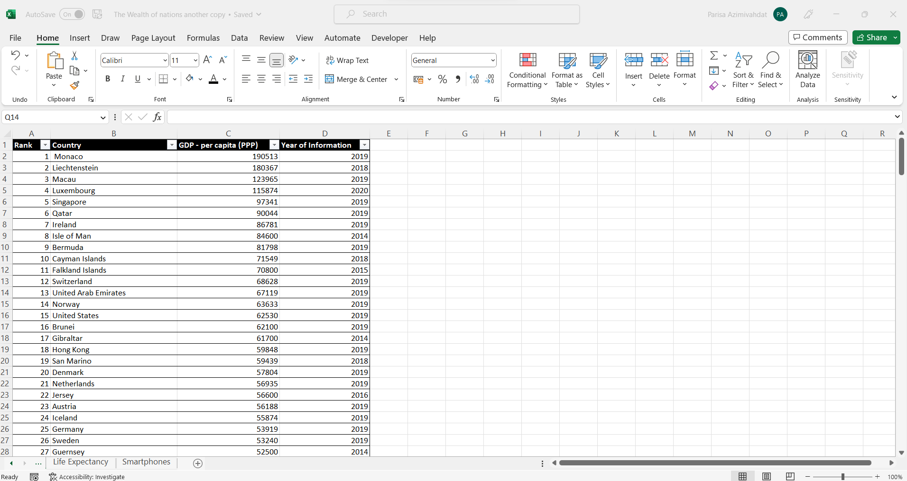

**The File tab is selected as shown here in a red box.**

Step2

Choose Info.

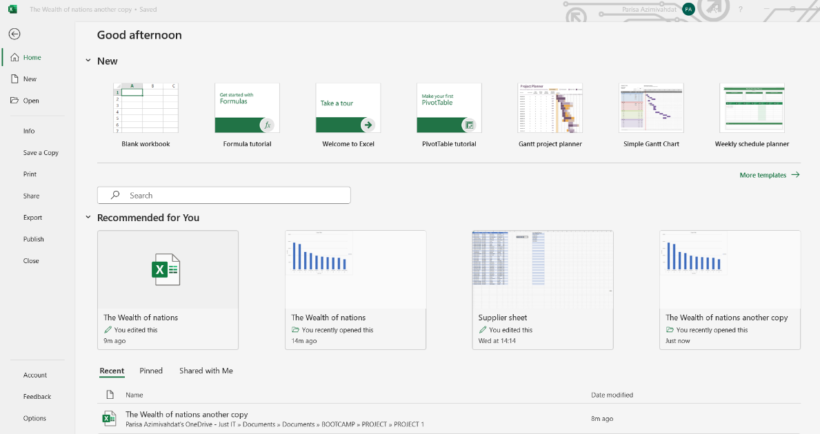**Click on the Info option on the side panel.**

Step 3

Select ‘Protect Workbook’.

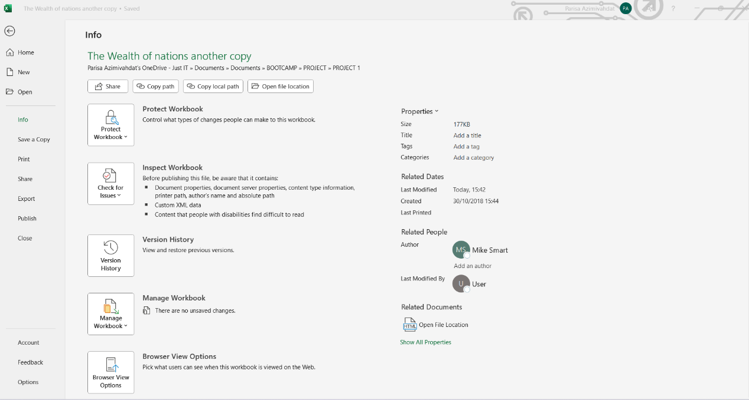**Select the action button inside the red box by clicking on it.**

Step 4

Choose ‘Encrypt with Password’.

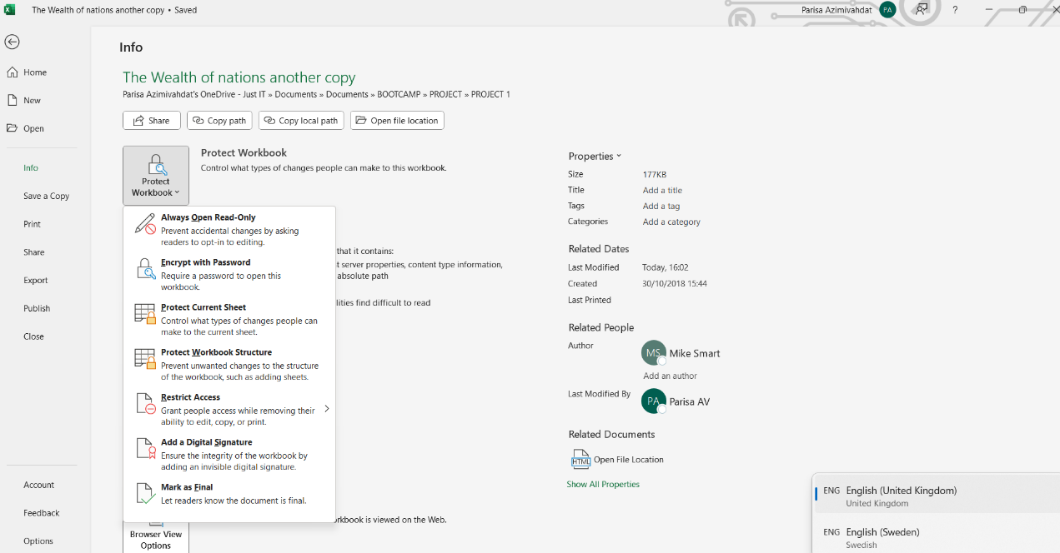**From the roll-down menu, click on ‘Encrypt with Password’.**

Step 5

Enter a Password in the Password box. Make your password unique with at least 12 characters, including upper- and lower-case letters, numbers and symbols.

[Microsoft.com |Create and Use Strong Passwords](https://support.microsoft.com/en-us/windows/create-and-use-strong-passwords-c5cebb49-8c53-4f5e-2bc4-fe357ca048eb)

**Enter your password in the box under ‘Password:’**

Step 6

Confirm your password by reentering it. You will need the password to be able to open the workbook.

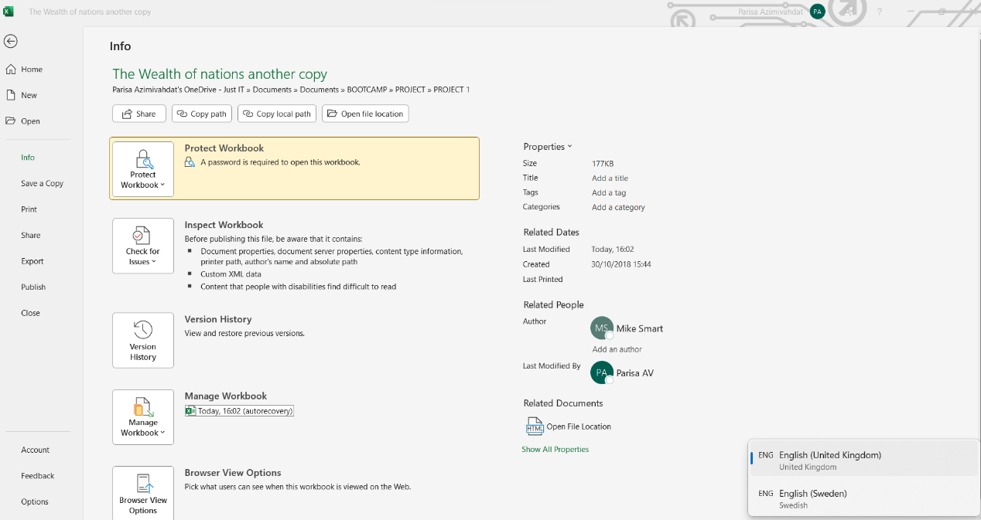**The workbook is now password protected as shown.**

1. Highlight column C and change the data to display in British Pound symbol.

Step 1

Select Column C.

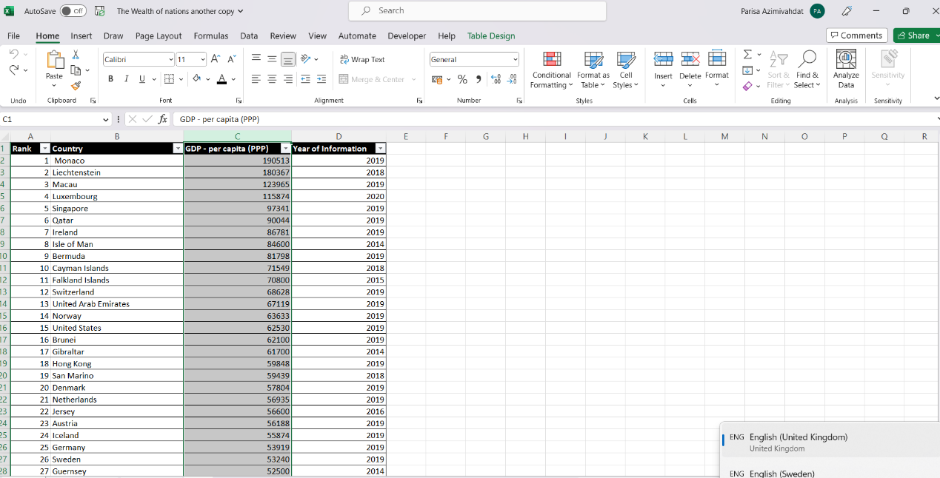**Column C highlighted in gray.**

Step 2

Alt1: Choose the ‘Accounting Number Format’ in the Number-group of the Home tab.

Alt2: Right click for the drop-down menu. Select the ‘Accounting Number Format’ on the top centre. Click on the down pointing arrow next to it.

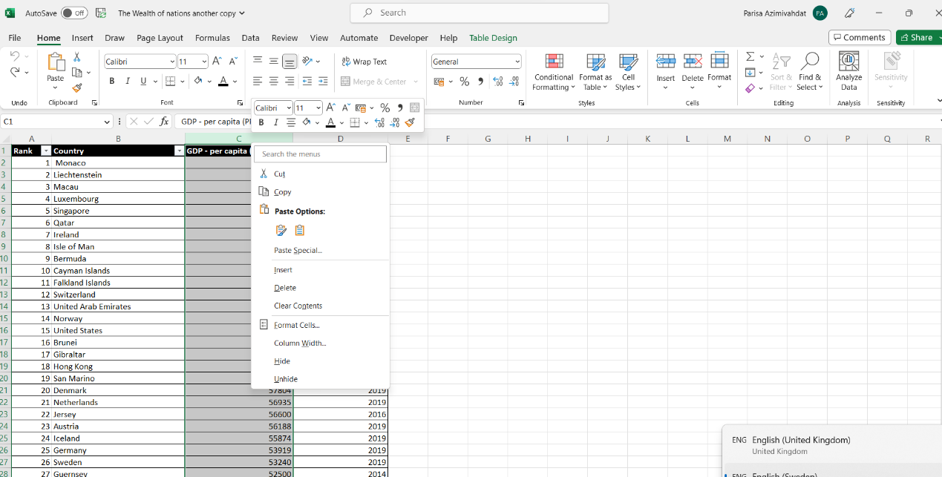**Hover over the top menu of the list to find ‘Accounting Number Format’.**

Step 3

Click on ‘£ English(United Kingdom’.

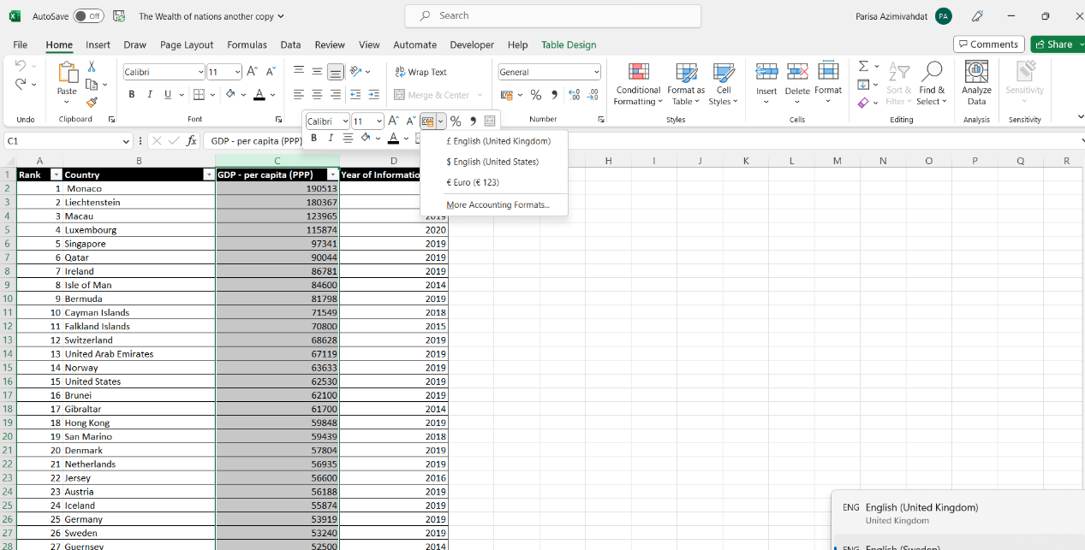

Step 4

The pound symbol is now included in Column C as the data type is formatted to currency.

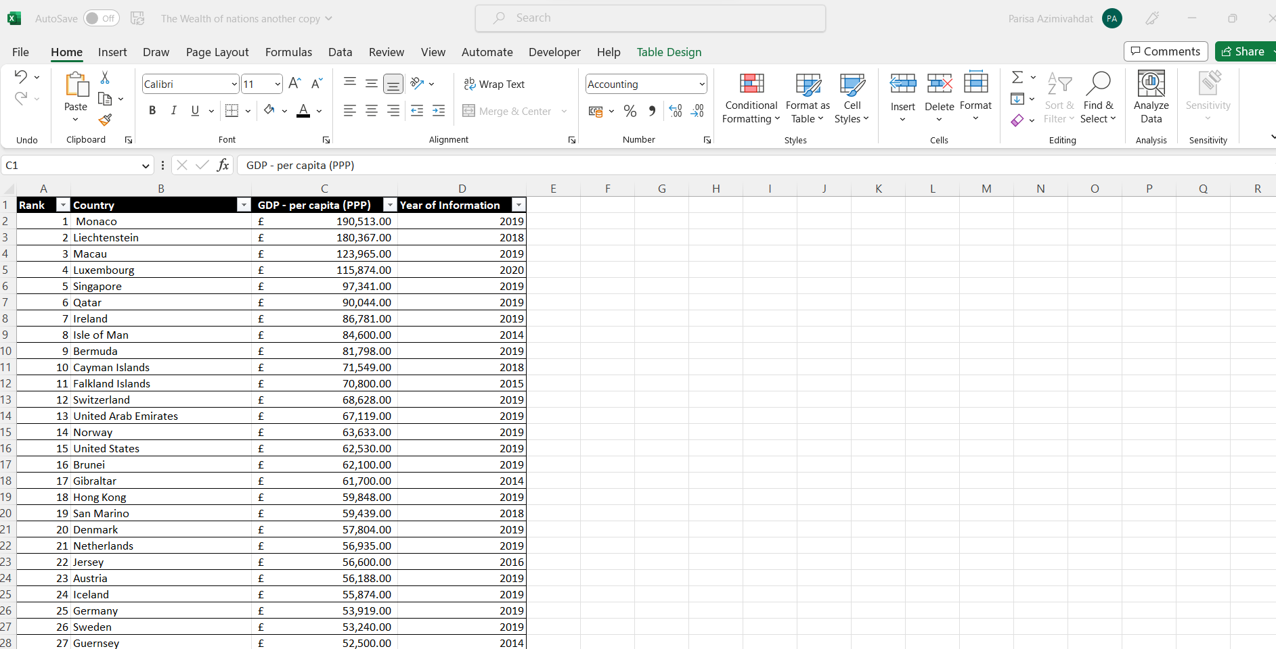

**British Pound £ Sign in the left side of all the cells indicating monetary values in the column.**

1. Turn the GDP sheet into a table.

The columns in ‘Wealth of The World’ are converted into a table.

[Microsoft.com| Create a Table in Excel](https://support.microsoft.com/en-us/office/create-a-table-in-excel-bf0ce08b-d012-42ec-8ecf-a2259c9faf3f)

Step 1

Select a cell in the data and choose ‘Format as Table’ in the Styles-group in the Home tab. Choose ‘Blue, Table Style Medium 16’ from the ‘Medium-group.

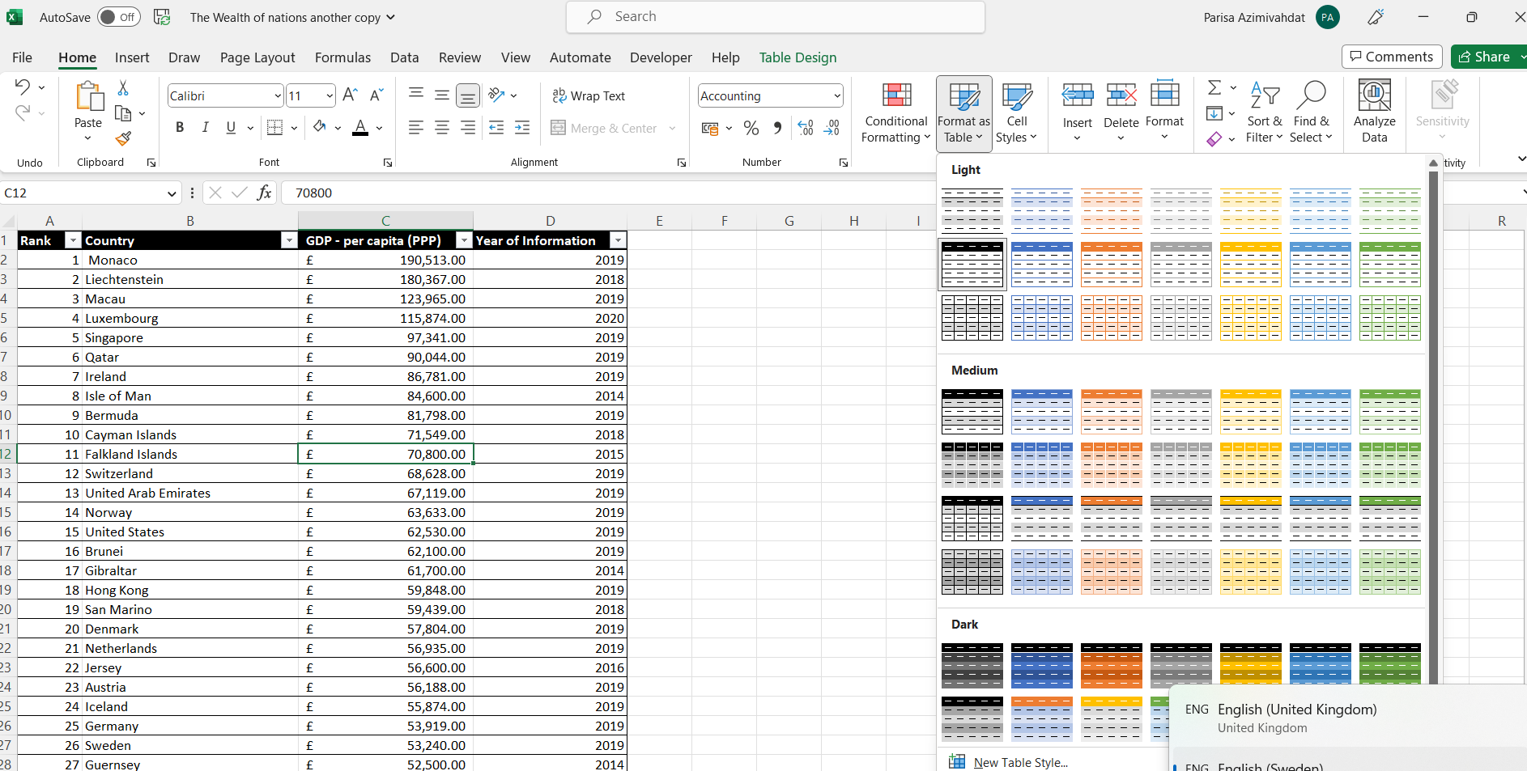**Select and cell and in the Home, tab click on ‘Format as Table’ in styles.**

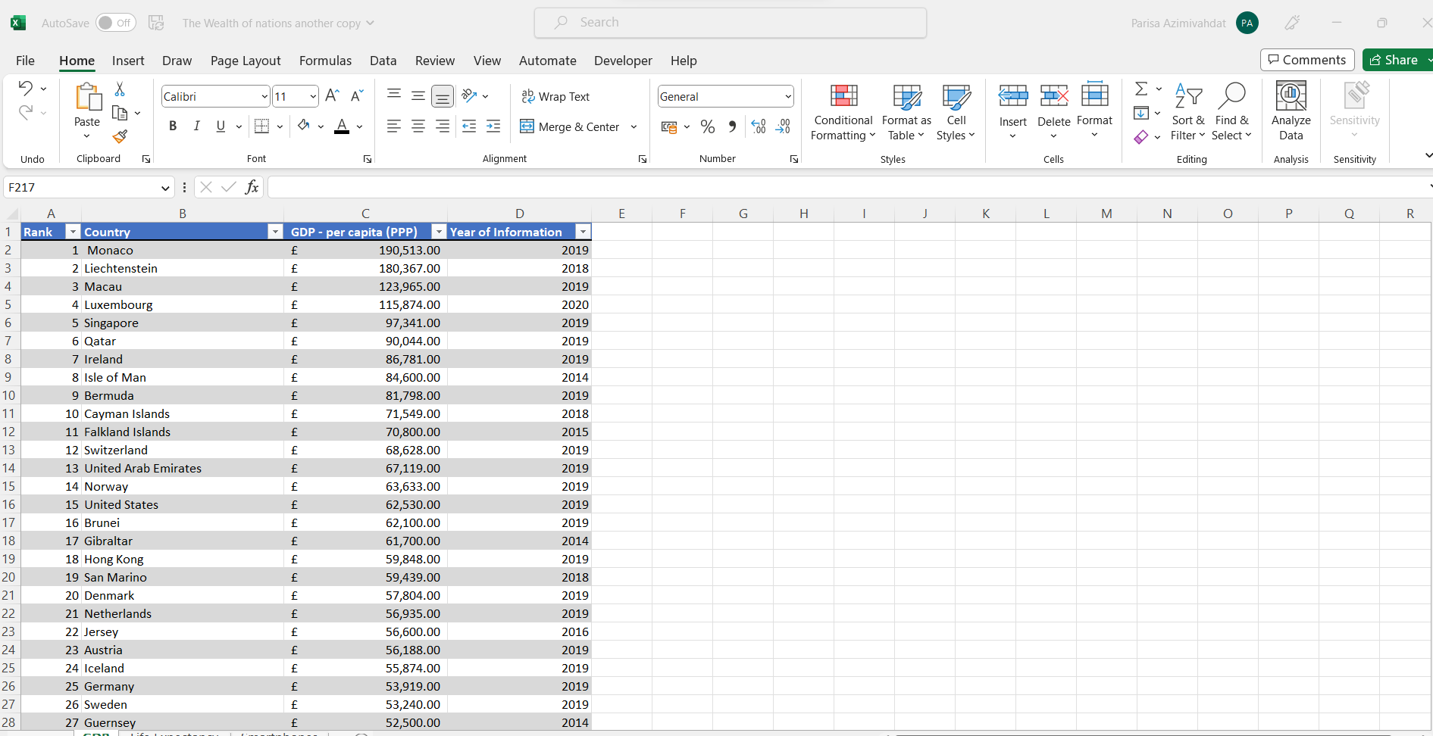**The table displaying ‘The Wealth of Nations’ is shown above.**

4.Filter the table to display only the information for 2019.

Step 1

Select the arrow on the column with the heading ‘Year of Information’ for the drop-down list.

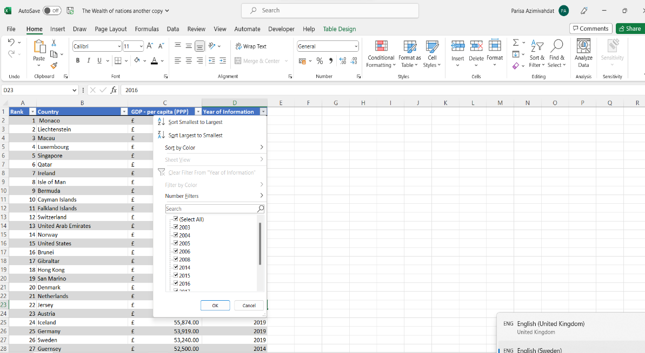**Note the list with the first ticked option ‘(Select All)’.**

Step 2

Unselect the first option,’(Select All), in the list displaying the options for the years with data.

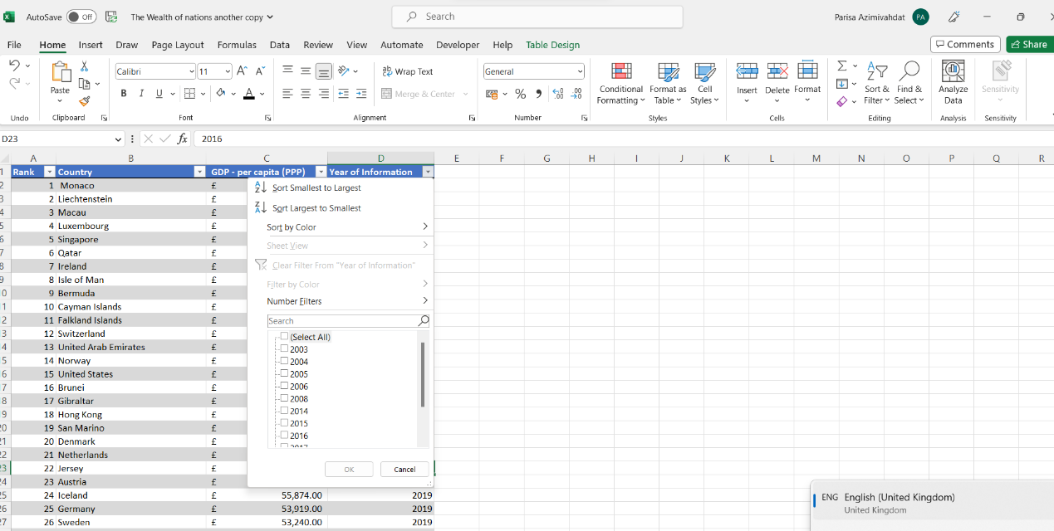**Untick the first item on the list with all the years.**

Step 3

Select the field for 2019.

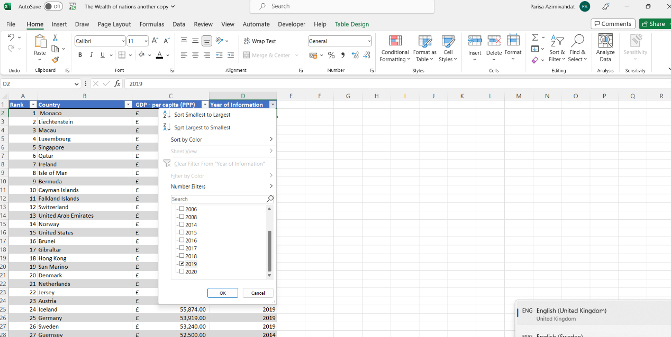**Tick the box next to ‘2019’**

Column ‘Year of Information’ is now filtered to exclude all data except the data in 2019.

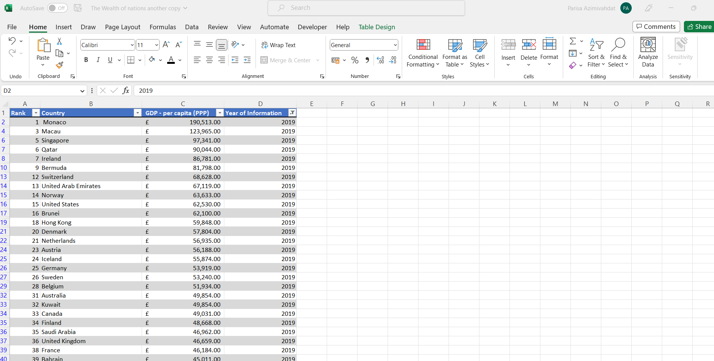**Column ‘Year of Information’ is showing the data in the year 2019.**

5. Next create a chart that will only display the following data ‘Rank, Country, and GDP - per capita (PPP). The chart can be anything as long as it is suitable.

1. Using your creative skills edit the chart.
   1. Add a title.
   2. Add X and Y axis labels.
   3. Make the chart visually pleasing

Step 1

For displaying the rank and GPD per Capita (PPP) of the country, a pivot table must be created.

Creating a pivot table with columns ‘Rank’, ‘Country’, ‘GPD- per capita(PPP)’.

[Microsoft.com | Create a Pivot Table to Analyse Worksheet Data](https://support.microsoft.com/en-us/office/create-a-pivottable-to-analyze-worksheet-data-a9a84538-bfe9-40a9-a8e9-f99134456576)

Step 1

Select the columns to be included in the pivot table.

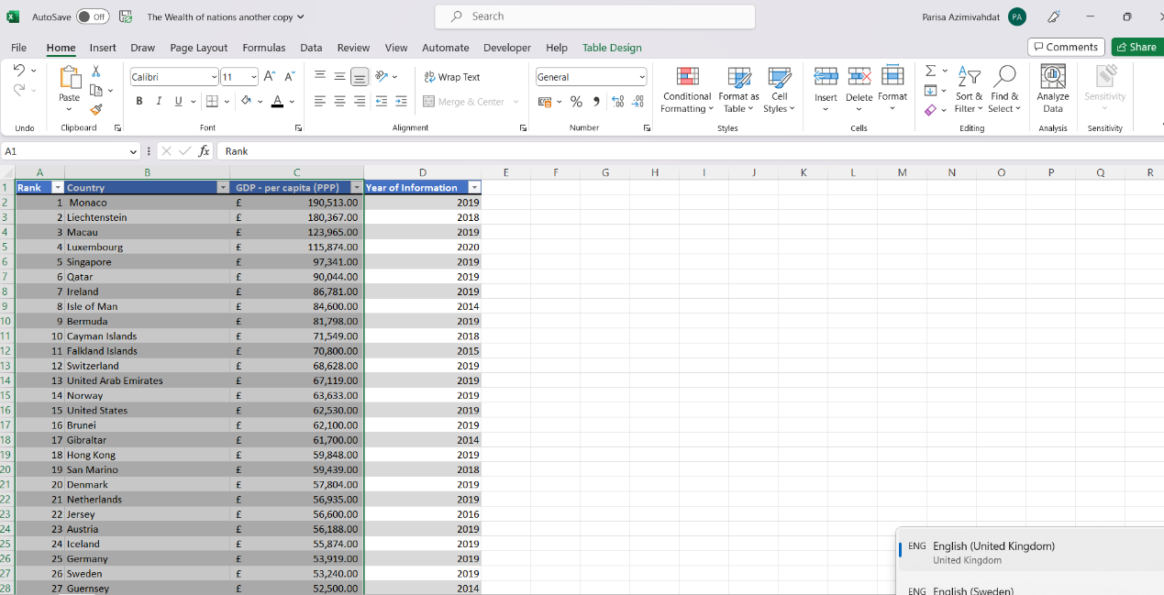**Highlight all cells in the Rank, Country and GPD- per capita (PPP) columns.**

Step 2

Alt1: Select from the Insert tab, the table-groups the Pivot table for the drop-down menu. Select then ‘From Table/Range’.

Alt2: Select ‘Recommended PivotTables’ and choose an option from the recommended pivot tables.

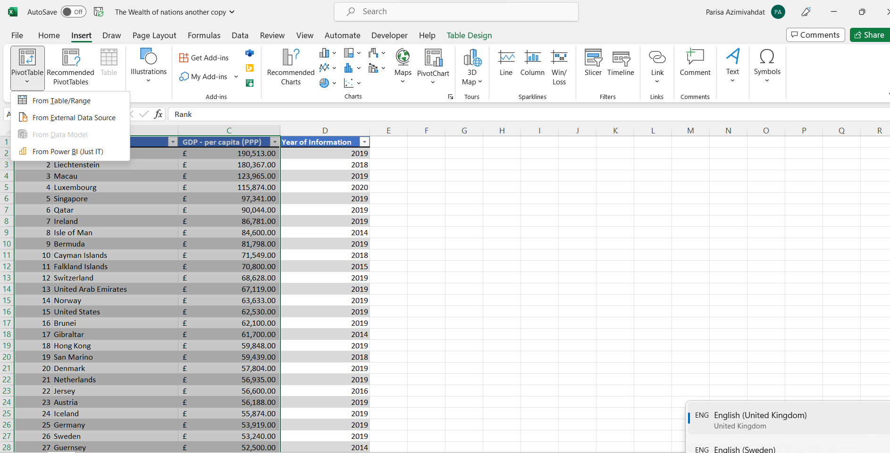**Click on Insert, then click on Pivot Table and choose From Table/Range.**

Step 3

See ‘Table 1’ by excel in ‘ Table/Range’. Select the place for the pivot table to be on a new sheet.

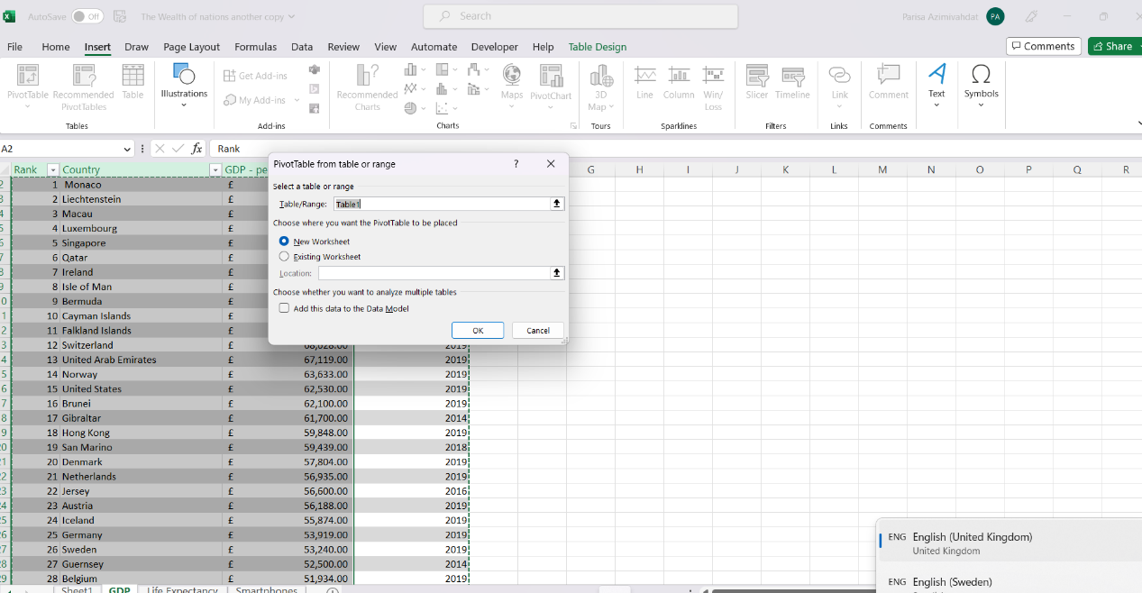**See the range in the box named ‘Table/Range’, and click on ‘New Sheet’**

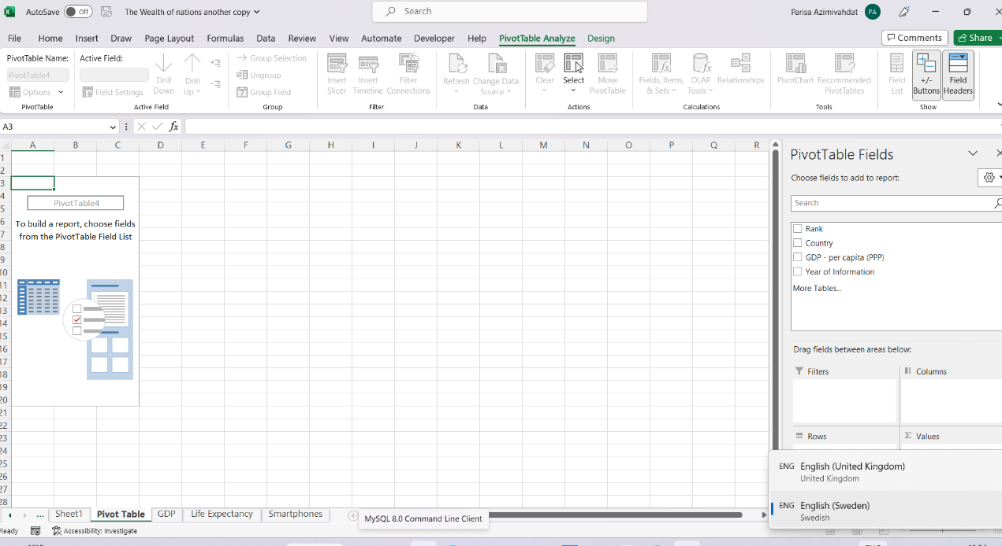**Rename the worksheet by double clicking on the tab and typing the name.**

Step 4

Choose the fields to add to the pivot table. See that the added fields can be removed by unticking the box.

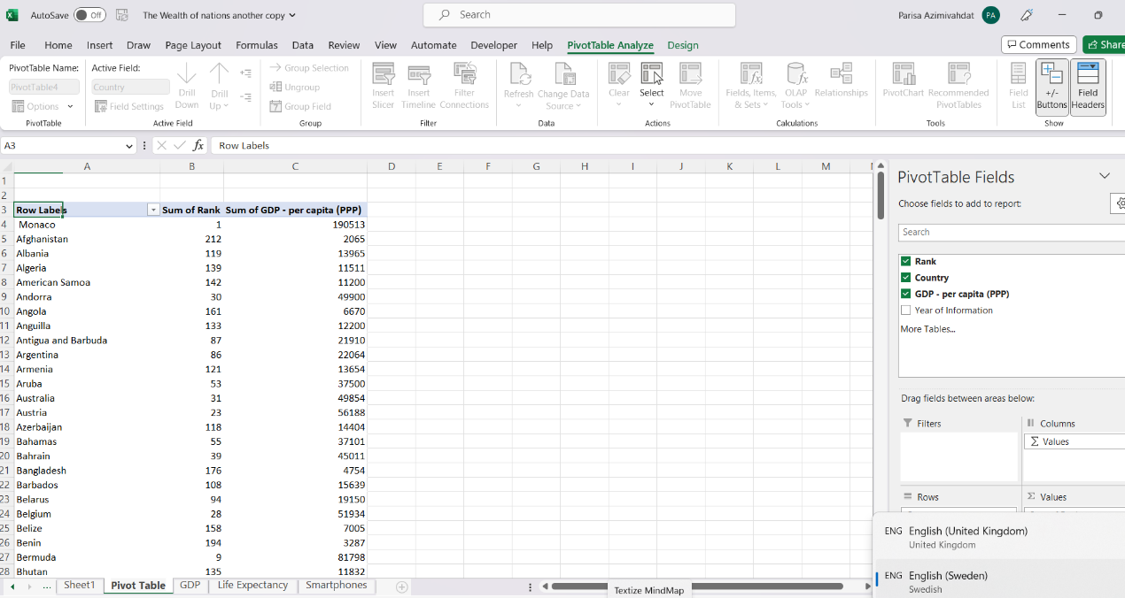**Tick the boxes for Rank, Country and GPD-per capita (PPP)**

Step 5

Drop the field ‘Rank’ into the box with the name ‘Filters’ on the Pivot Table fields’ panel on the right side.

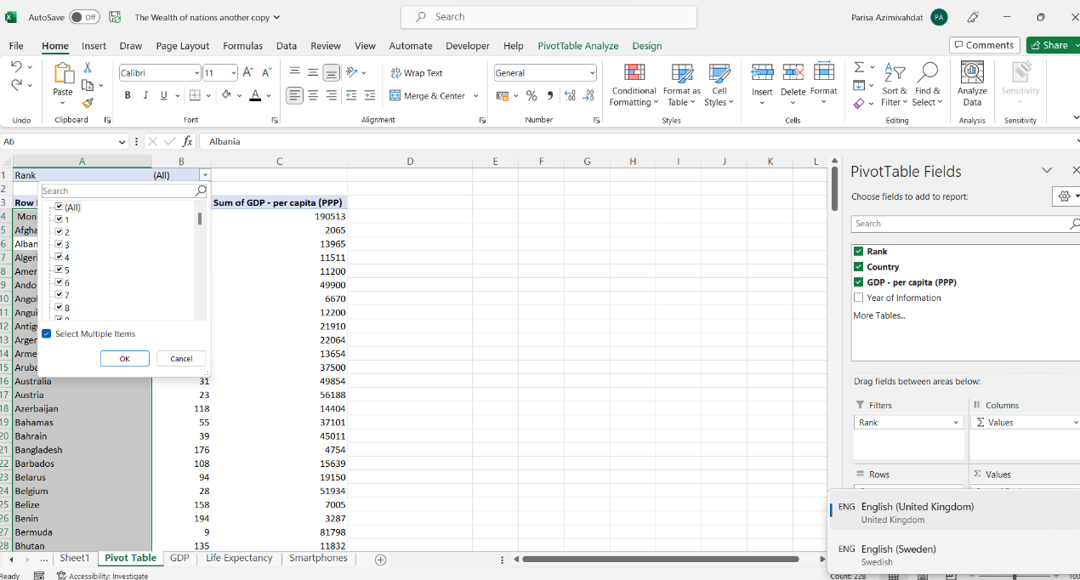**See the drop-down list with the ranks after this field is placed**

**in the Filters’ box.**

Creating a chart

[Microsoft.com | Create a Chart](https://support.microsoft.com/en-us/office/video-create-a-chart-4d95c6a5-42d2-4cfc-aede-0ebf01d409a8)

Step 1

Select any cell in Table 1. Click on Insert and choose line charts from the charts-group.

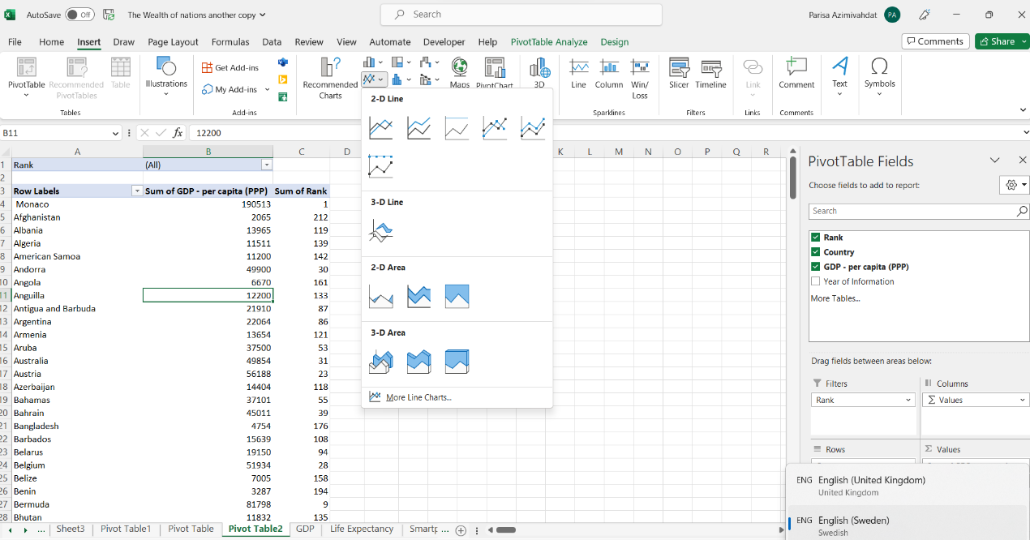**Click on the button with lines in the Charts-group.**

Step 2

Choose the first option in ‘2-D Area’.

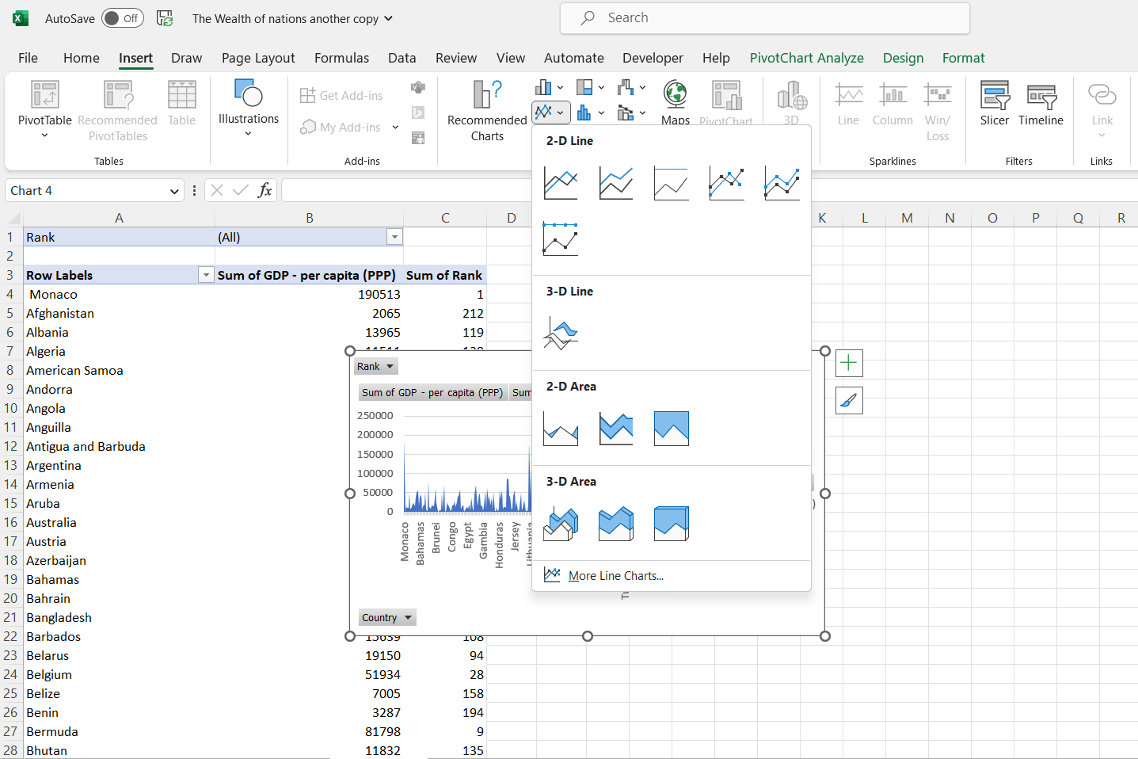**Click on this chart.**

Step 3

Click on the arrow on the ‘Rank’ tab in the ‘Values’ box and choose ‘Remove Field’.

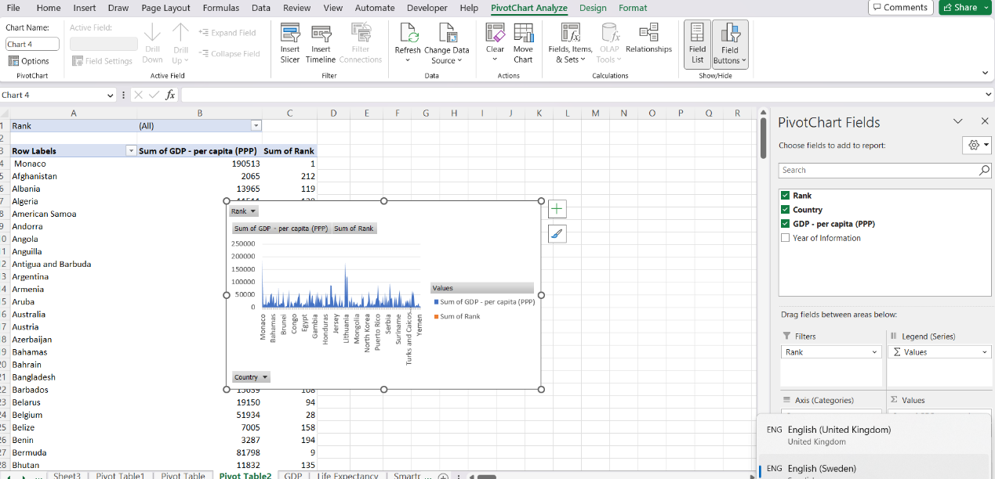**Remove Rank from ‘Values’ for Sum of GPD- per capita (PPP) in the legend.**

Step 4

Click on the arrow on the ’Rank’ button and choose ‘ Move to Legend Fields (Series)’.

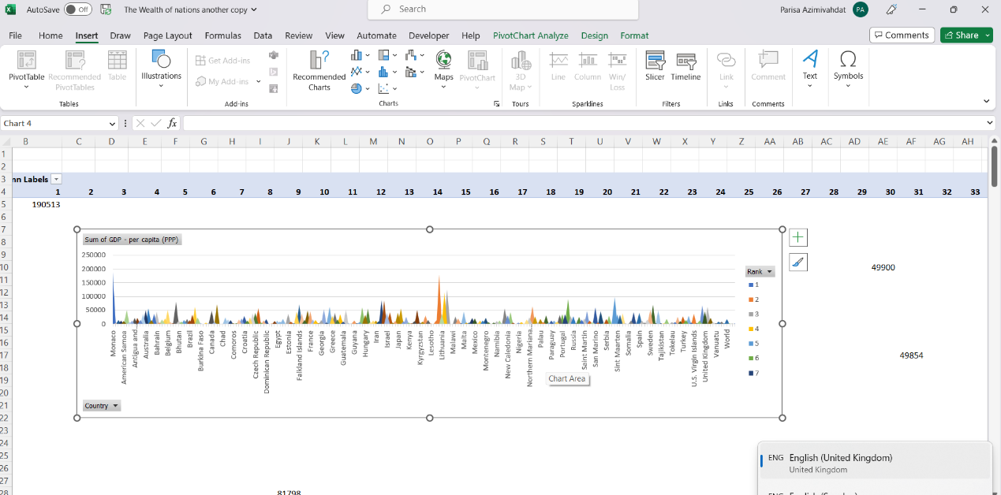**Note the legend is now filtering Rank.**

Step 5

Format the chart by clicking on the x or y axis. ‘Chart Style’ will then appear in the corner of the chart.

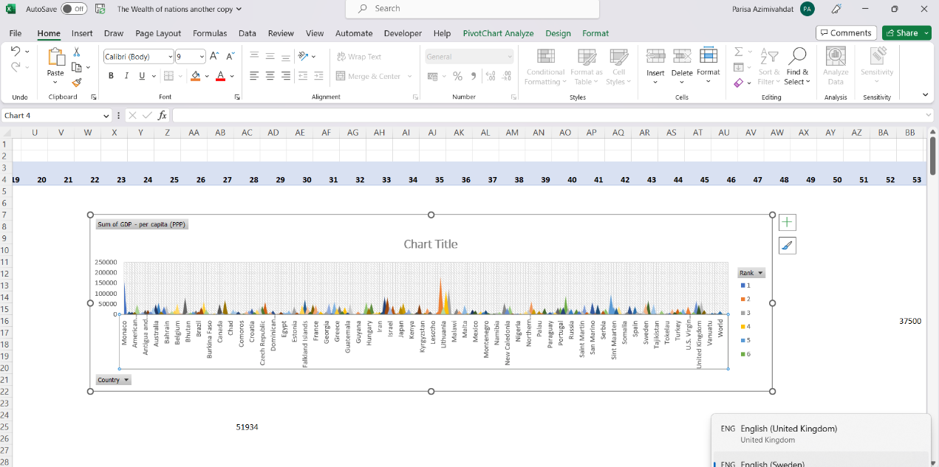

Click either on the number on the y axis or the countries on the x axis for the Chart Style to be visible in the corner. Hover on the icon to see its name.

Step 6

Double click on the title and rename the chart.

**Rename and format the name.**

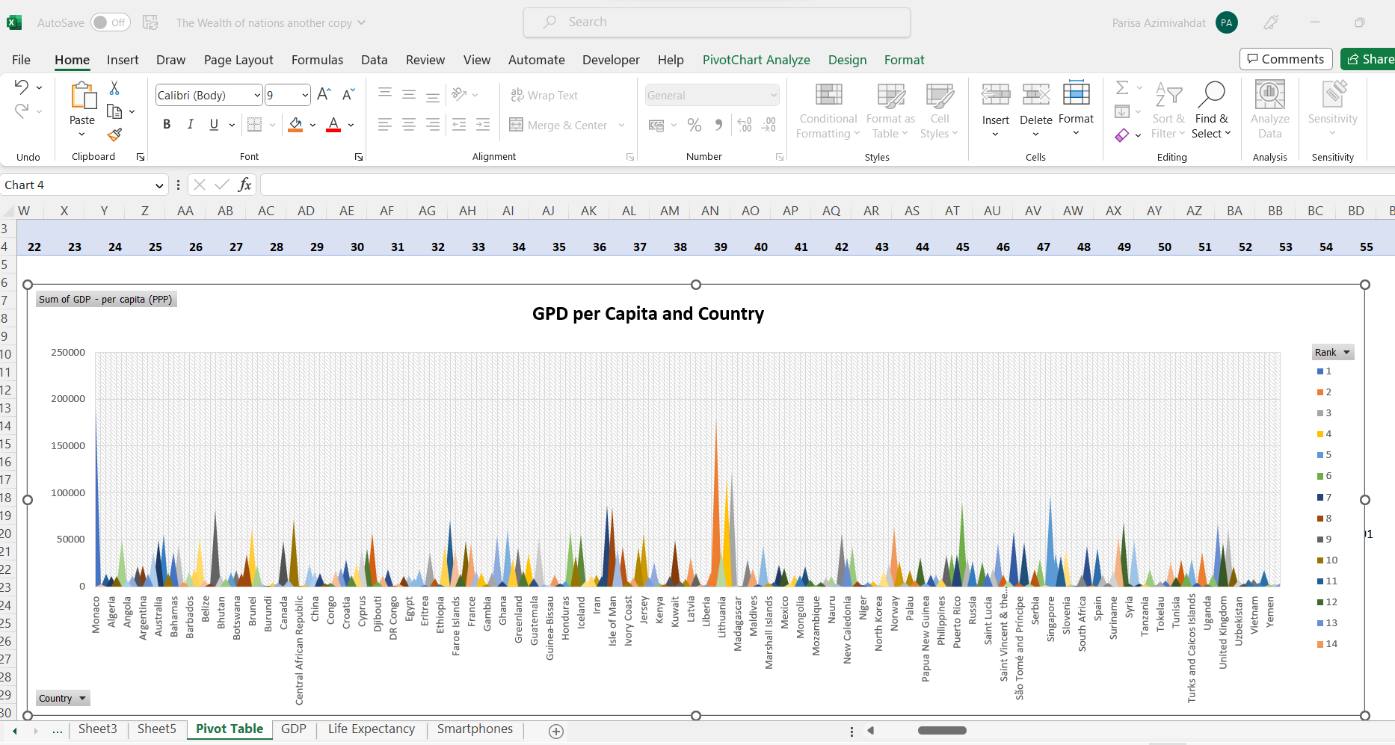

Step 7

One of the many ways to filter the chart by the Rank of the countries is to choose a parameter for the ‘lable Filter’. The parameter ‘Less Than’ can be set for less than 20 which will display the countries with ranks less than 20.

**Click on the arrow on the ‘Rank’in the legend, and choose ‘Value Filter’ and ‘Less Than…’**

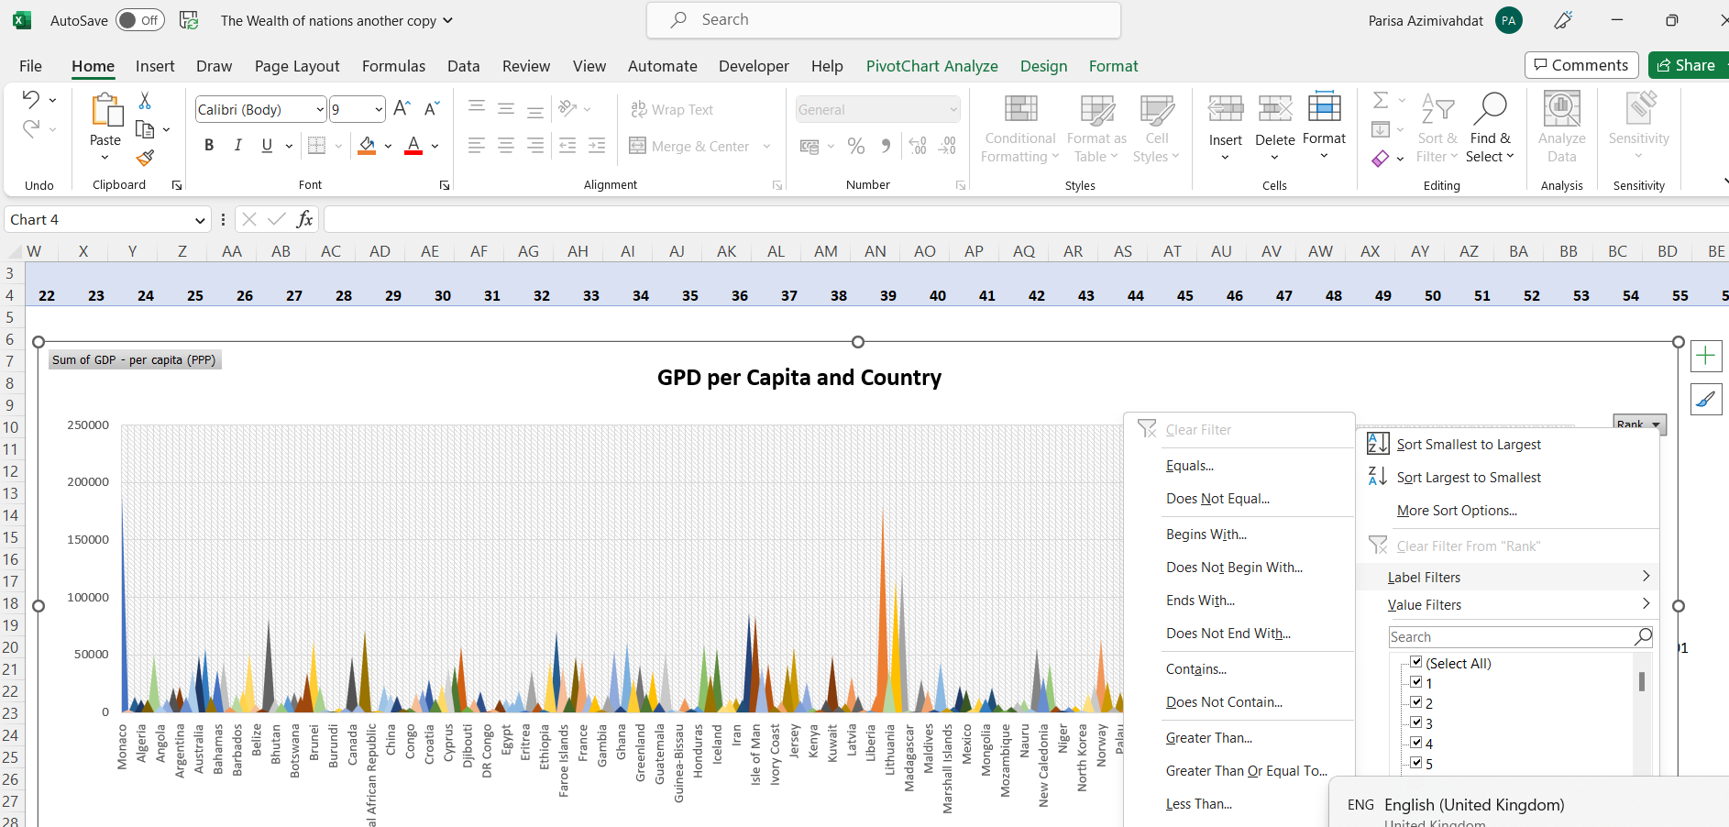**Click on the arrow on the ‘Rank’in the legend, and choose ‘Value Filter’ and ‘Less Than…’**

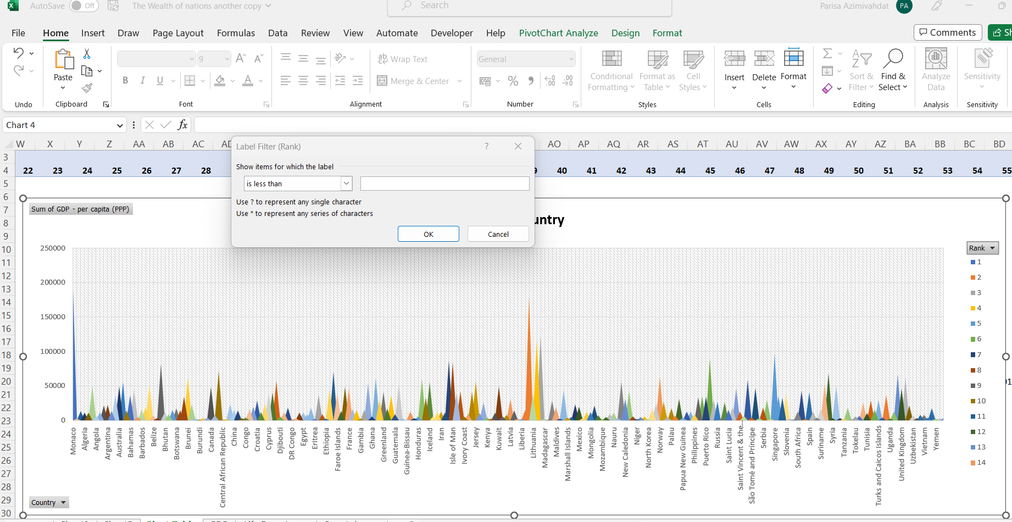**Type 20 or a number of choice in the empty box and click OK.**

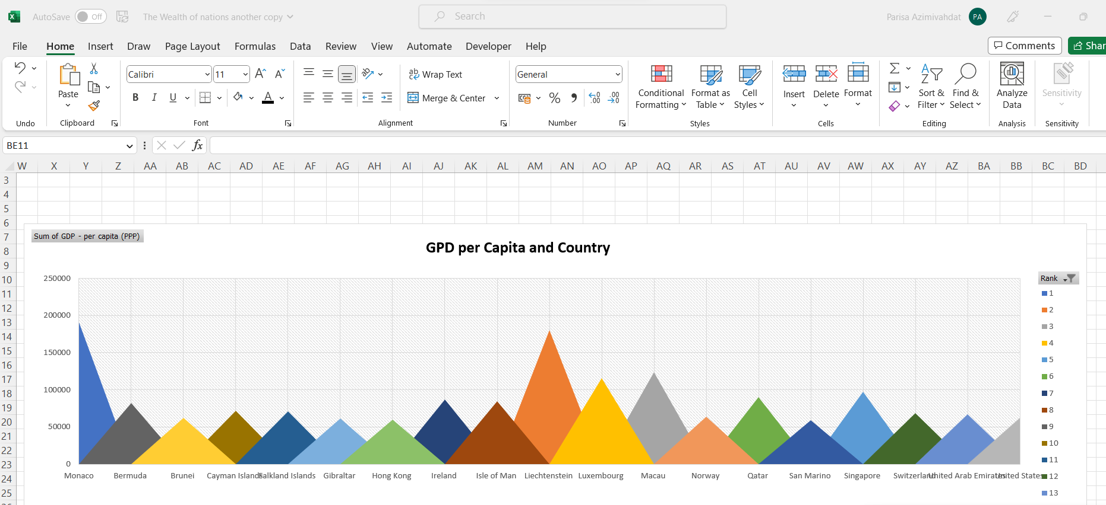

**Chart is now displaying the top 20 countries and their GPD-per capita (PPP)**

Step 8

Right Click on any of the fields and choose ‘Hide All Filed Buttons on Chart’. Insert a text box for the horisontal and vertical axis and name it.

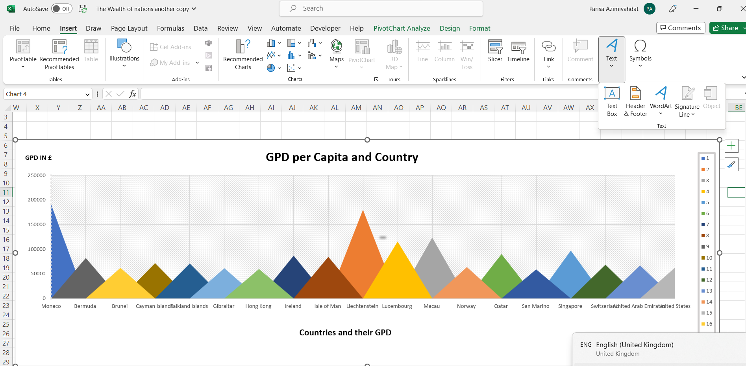

**Insert a text box for the x and y axis and name and format them.**

The Slicer allows for selecting values by rank number or multiple ranks. The right click drop-down menu has options for removing it or sending it to the front or back of the chart. It can also be resized to show one value seen below.

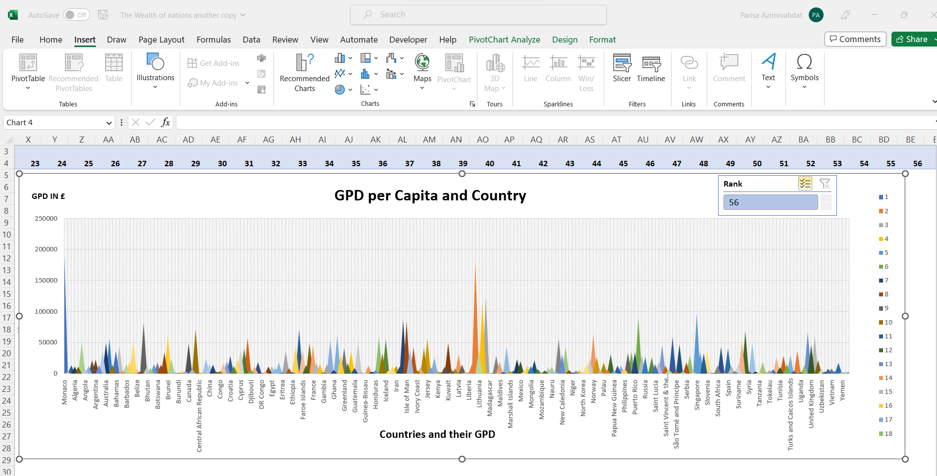

Insert a slicer from the Filters-group in the Insert tab. Choose Rank among the fields.

1. Move the chart to a new sheet tab and label with a suitable name.

The worksheet is renamed from Pivot Table to GPD per Capita and Country.

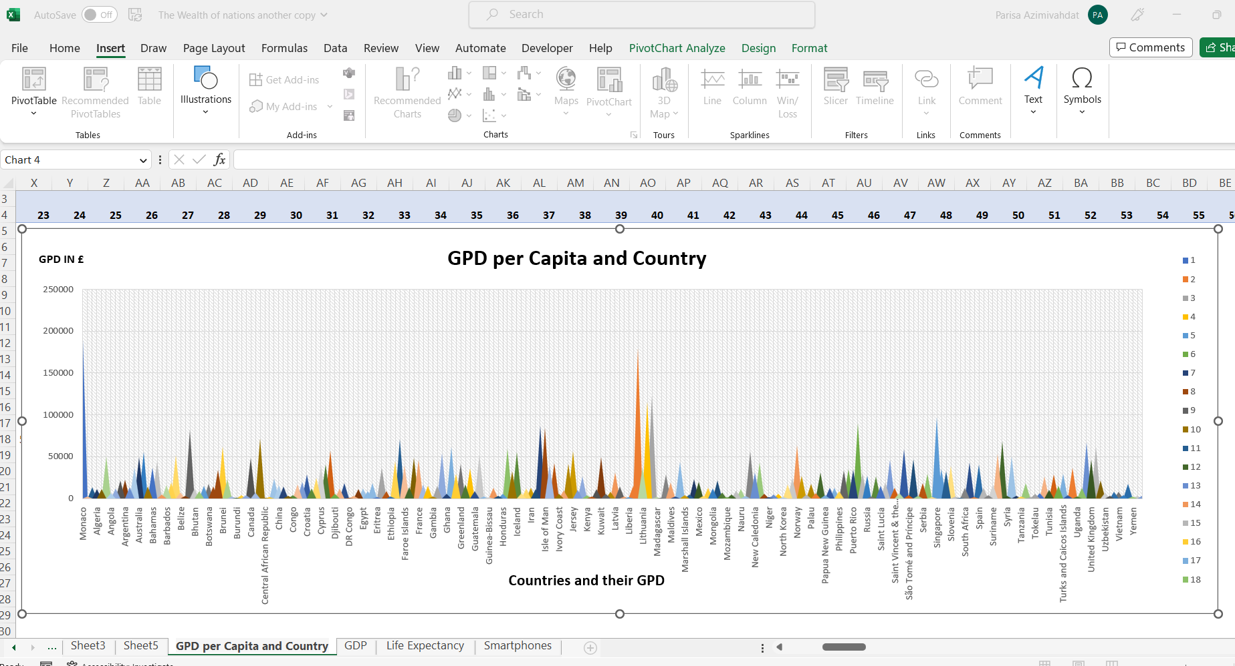

1. Create a sort for the top 20 highest ranking counties.

The slicer will slice out a single country by choosing a rank number. For 20 highest ranks, choose the Multi option from the right click drop-down menu and select the numbers 1 to 20 by clicking on them individually.

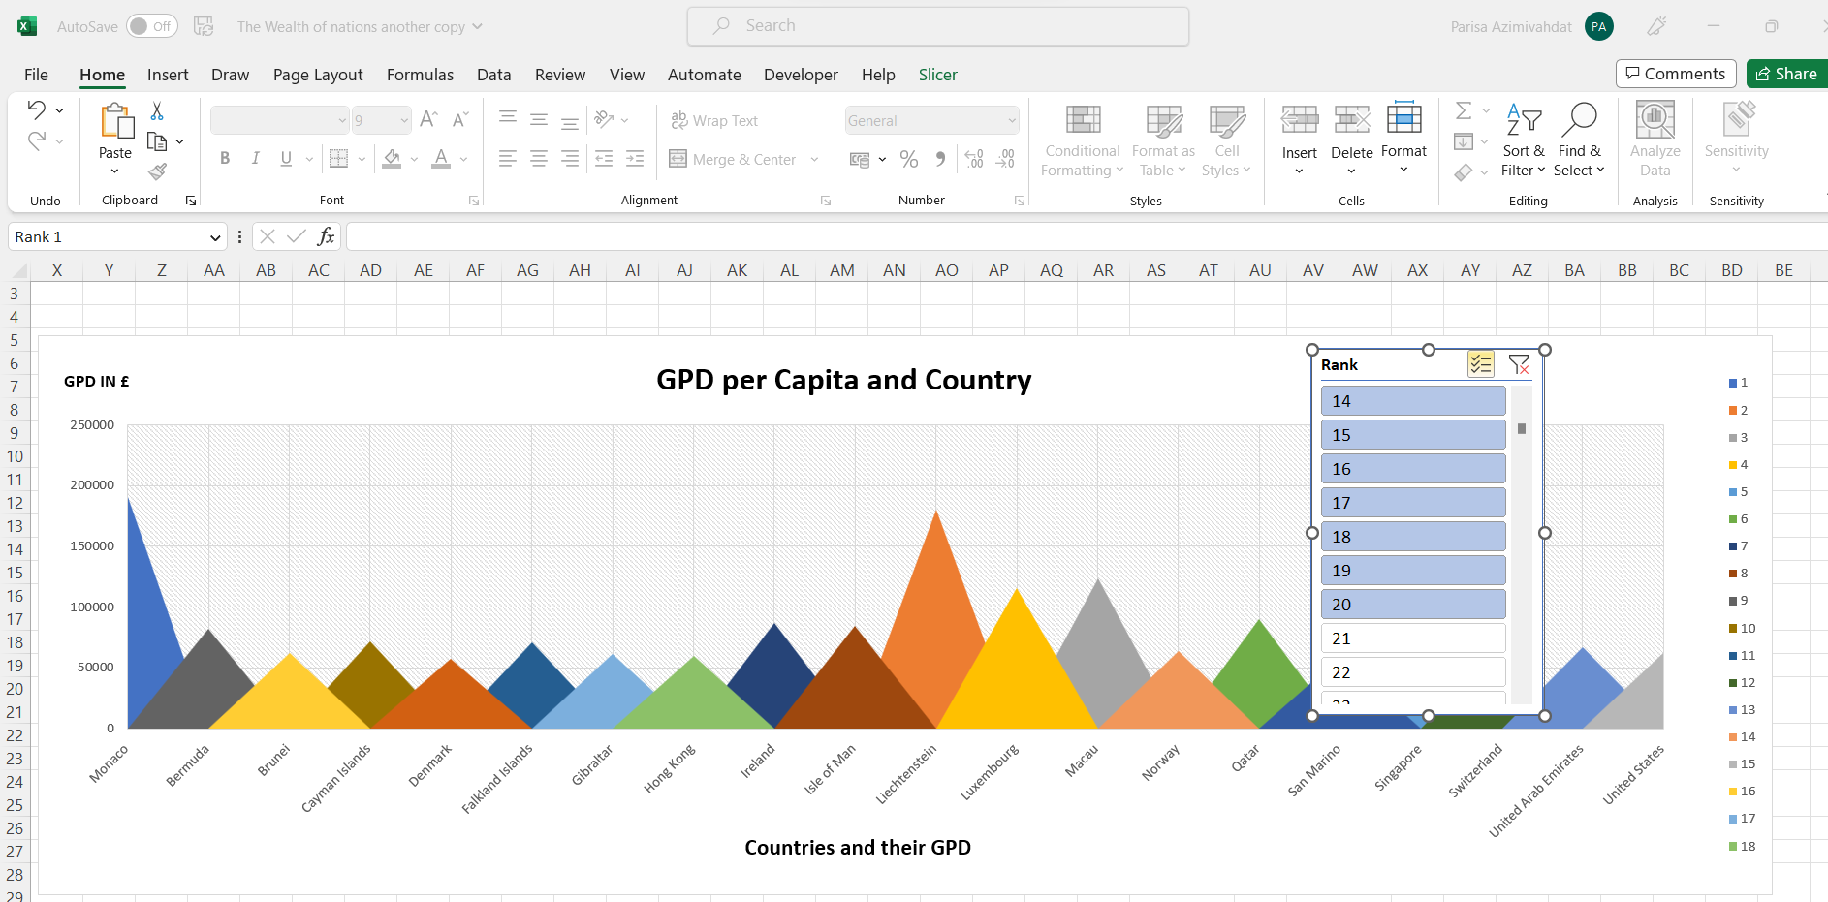**Right click on the Slicer and choose Multi-Select Rank. Then click 1-20.**

1. Next create a new Bar chart to display the 20 highest ranking countries from your sort and then move the chart to be underneath the table, as shown below.

Step 1

Create a new worksheet with a pivot table created from ‘GPD- per capita (PPP)’. Filter the top 20 highest ranking countries.

Step 2

It is now time to format and style the chart.

1. Rename the chart.
2. Format a single value legend.

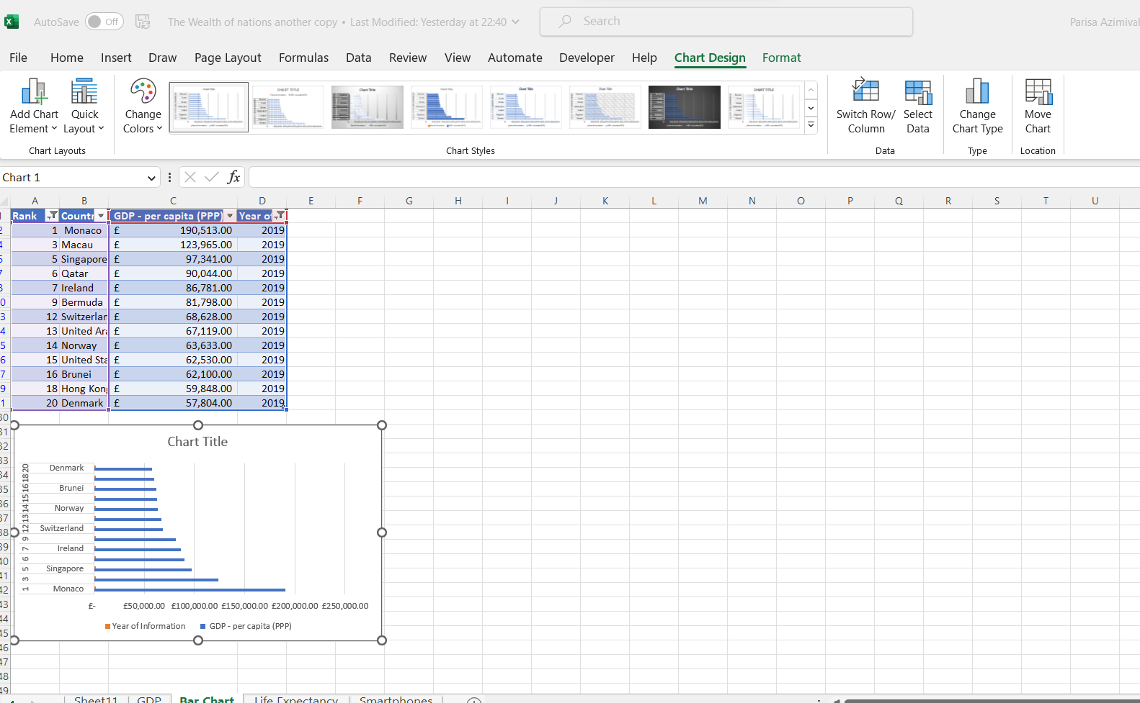**Enter the name of the chart and delete ’Year of Information’.**

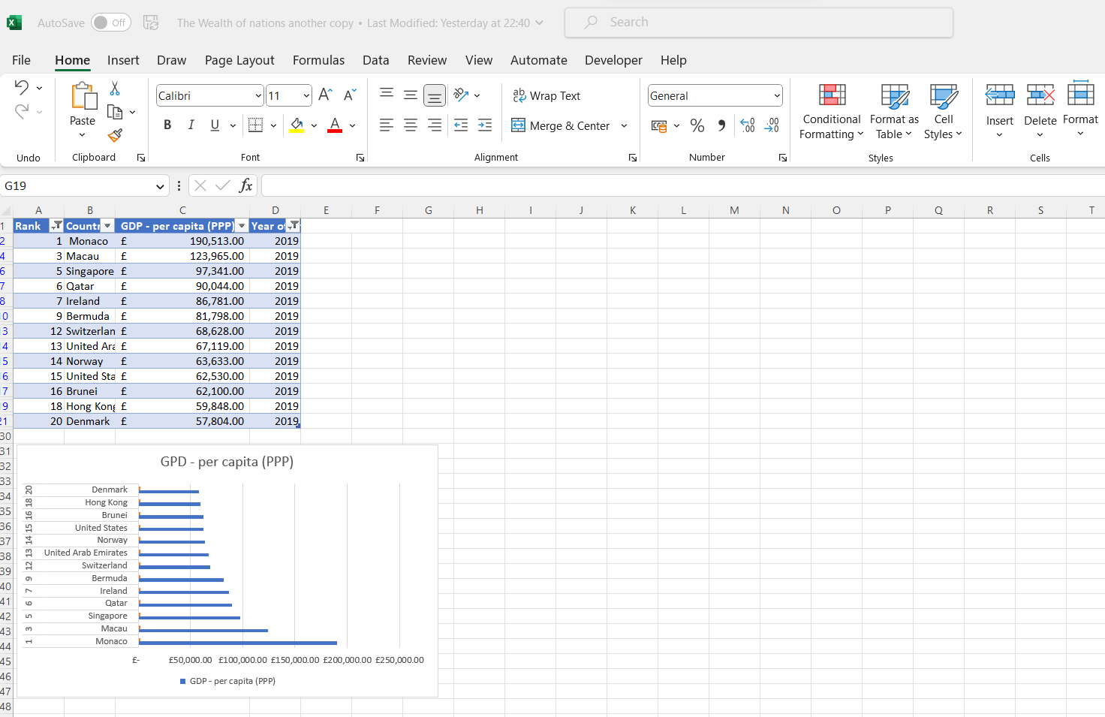**Resizing the chart will add all the country names on the vertical x-axis.**

1. Colour the background by highlighting the area underneath the table as shown below. Find the add a fill colour icon and select a colour.

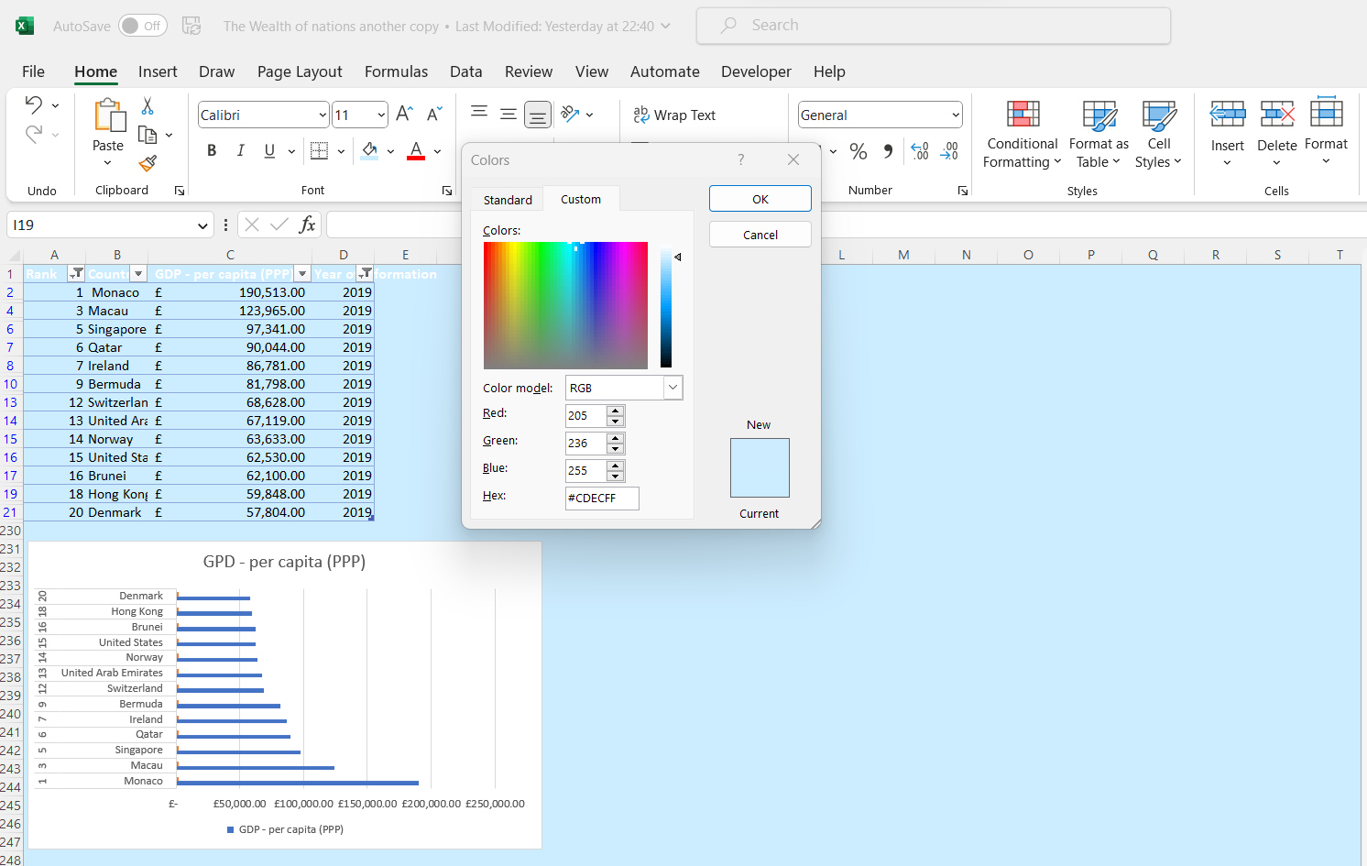**The background colour model and Hex characters.**

1. The next task is to create 3 macro buttons, print the sheet, Save the file, and copy the sheet. To copy the sheet in a macro you highlight the area to be copied then right click copy then stop the macro. Next assign the macro to the copy button.

[Microsoft.com | Create a Macro](https://support.microsoft.com/en-us/office/quick-start-create-a-macro-741130ca-080d-49f5-9471-1e5fb3d581a8#:~:text=If%20you%20have%20tasks%20in,your%20mouse%20clicks%20and%20keystrokes.)

[Microsoft.com| Assign A Macro to A Button](https://support.microsoft.com/en-us/office/assign-a-macro-to-a-button-728c83ec-61d0-40bd-b6ba-927f84eb5d2c)

Step 1

Click on ‘Record Macro’ in the Cod-group in ‘Developer’. Record copying, saving, and printing the worksheet to a file. When completed stop the recording.

Step 2

In ‘File’ choose ‘Options’, and ‘Quick Access Toolbar’. Under ‘Choose Commands From’ find ‘Macros’ and select it. Add all the macros recorded and customize the icon.

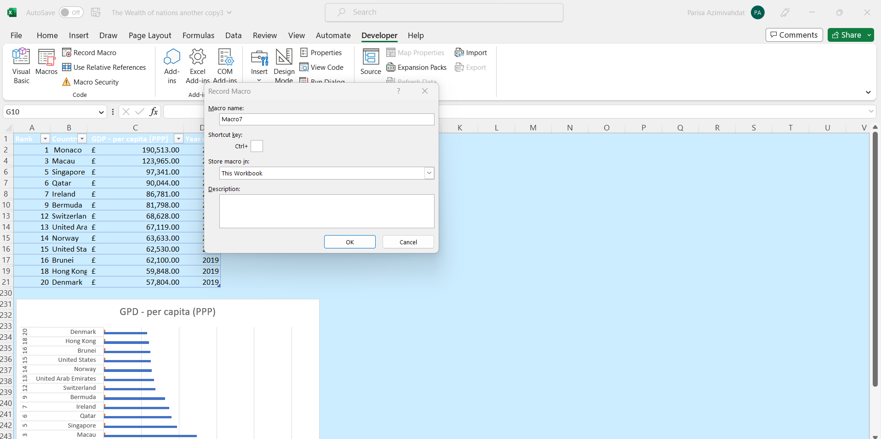**Fill out the fields for Macro name and Description. Store the macro in the same worksheet or a new.**

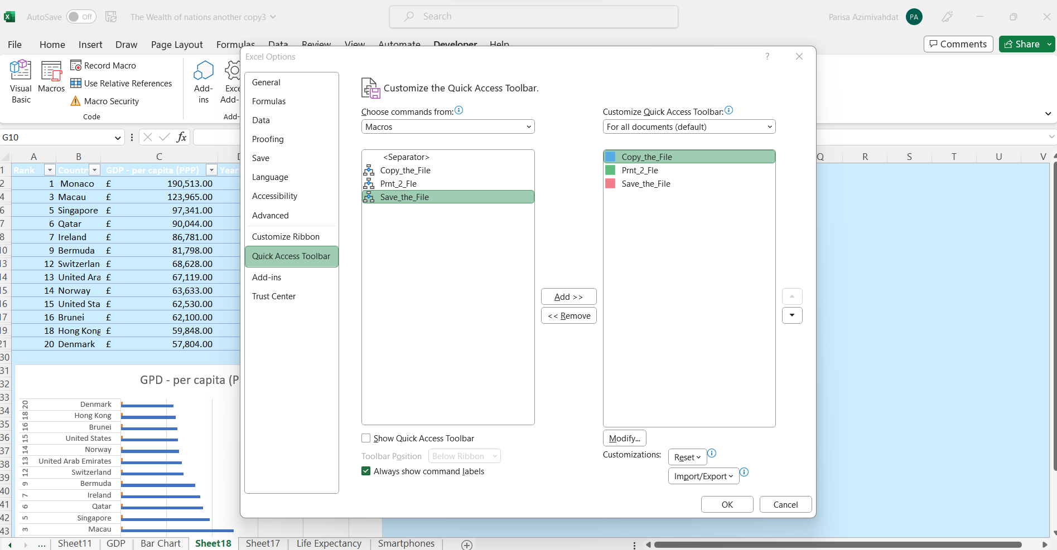

Add the Macros to the right side panel and choose an icon in Modify.

1. Using the copy macro, copy the sheet and then paste it into a new word document keeping the formatting. Give the page a title ‘GDP (Gross domestic product)’.
2. Save your document as ‘Word Gross domestic product report 1.’

[World Gross Domestic Product Report1](https://justit831.sharepoint.com/:w:/r/sites/SkillsBootCamp-SoftwareDeveloper21-22/_layouts/15/Doc.aspx?sourcedoc=%7BCCB240E1-91CF-430A-A995-48603F2EAA5F%7D&file=Word%20Gross%20domestic%20product%20report1.docx&action=default&mobileredirect=true)

1. Before we finish with our excel table ‘Gross domestic product’ sheet, we will add a header and footer to our table.
2. Enter your name and GLA DATA 1 in the three boxes.
3. In the footer add today’s date then Assignment 1 and lastly Data Visualization.
4. Return your view to normal.
5. Save your table as ‘Excel Gross domestic product report 1’.
6. Close your word document only.

[Excel Gross Domestic Product Report1](https://justit831.sharepoint.com/:x:/r/sites/SkillsBootCamp-SoftwareDeveloper21-22/_layouts/15/Doc.aspx?sourcedoc=%7B5D2B614E-8B26-453D-AE1D-C49DE06FEBC0%7D&file=Excel%20Gross%20domestic%20product%20report1.xlsm&action=default&mobileredirect=true)

Task 3 – Tableau

1. Import Data
2. Set Relationships
3. Check Data types.
4. Build Charts
5. For counts of Null Values, select the Filter Option
6. Build your Dashboard.

1)Import Data

Step 1

Open Tableau Desktop.

From the ‘Connect’ panel on the left side, choose ‘Microsoft Excel’ and double click on ‘ The Wealth of Nations’ to open the file from the hard drive.

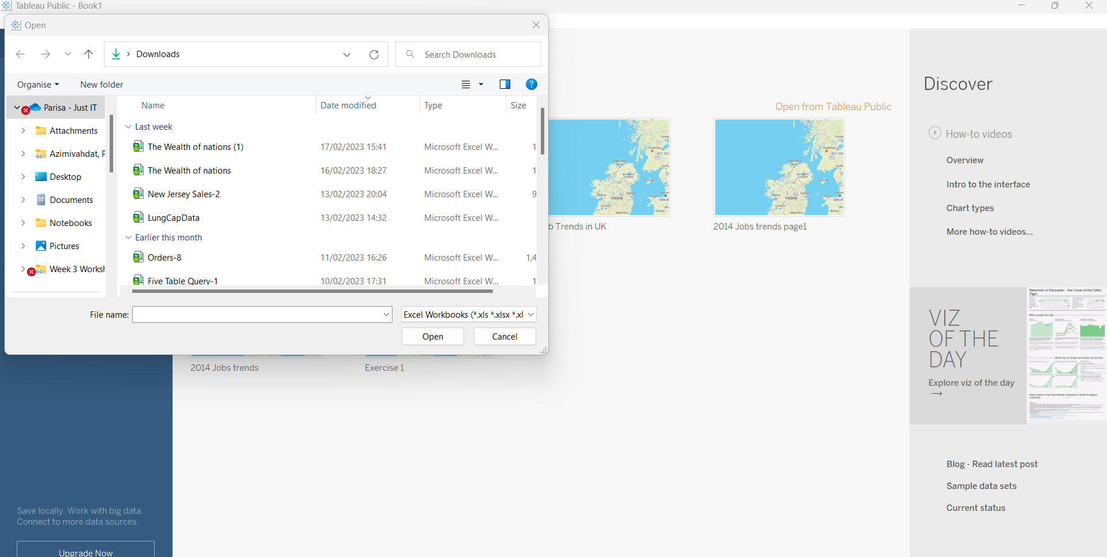

We don’t have to turn on the Data interpreter because ‘Wealth of Nations’ is clean and structured data.

**The tables under ‘Sheets’ on the le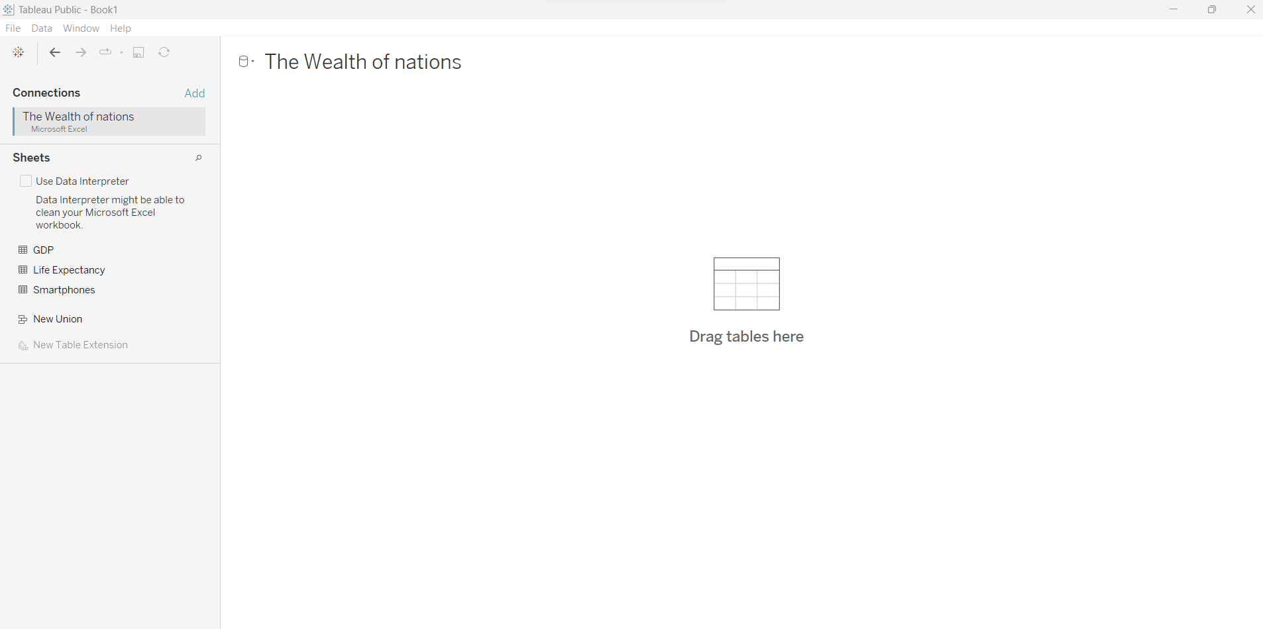The tables under ‘Sheets’ on the left side are marked in red.**

2) Set Relationships

Step 1

Drag and drop two of the three tables into the canvas as shown below.

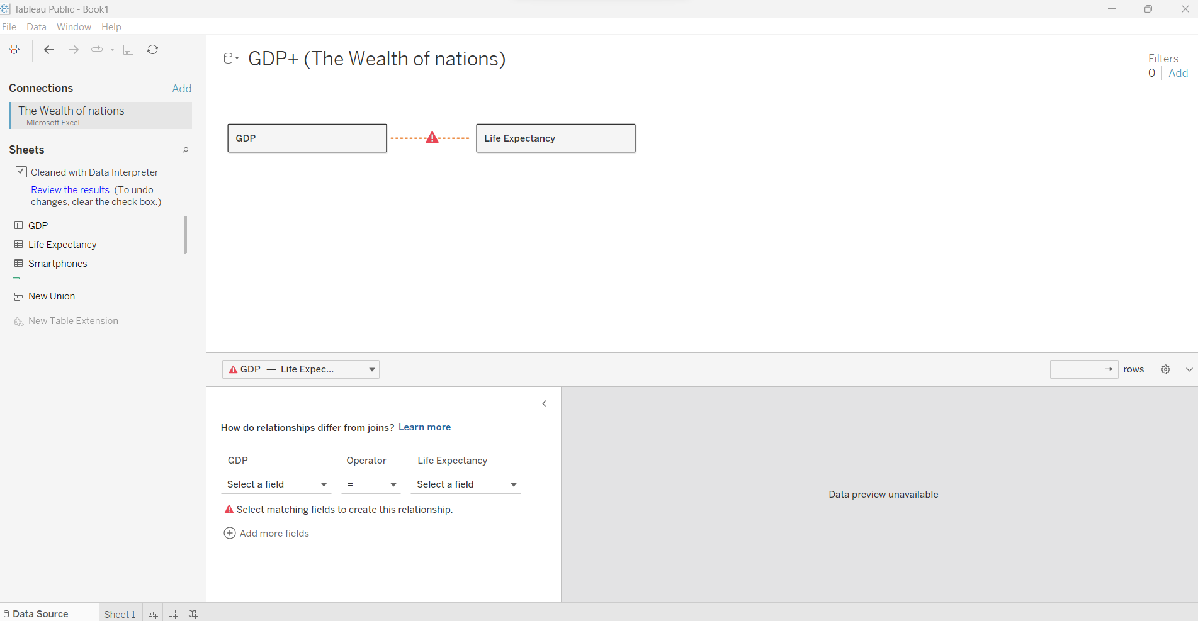**Scroll through to see which two fields are similar in both tables.**

Set the relationship between ‘GPD’ and ‘Life Expectancy’ by finding the column ‘ Country’ in both tables and making sure the operator is set to equal or ‘=’ between them.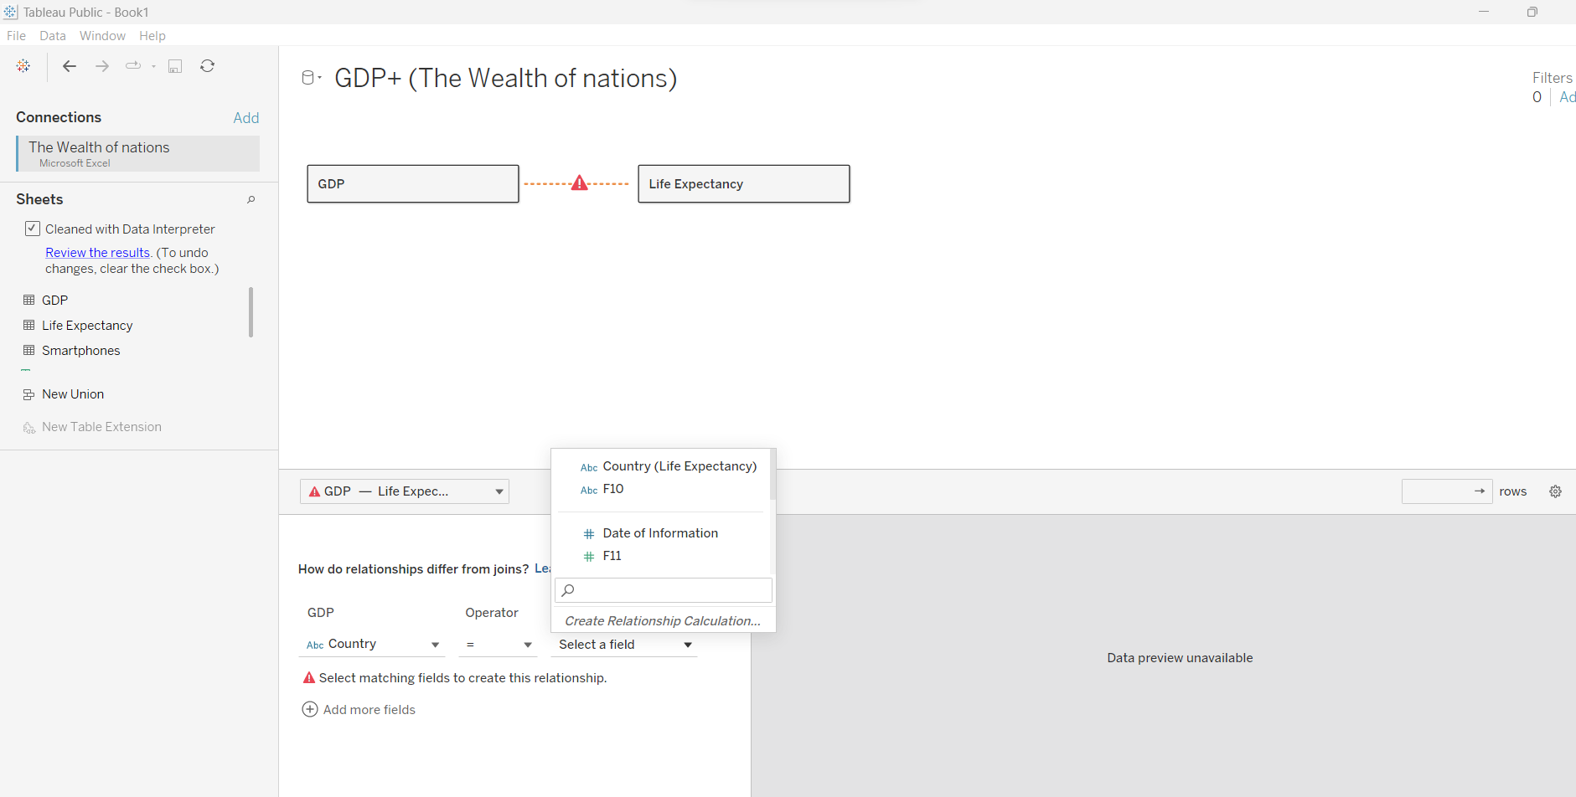**Find the list of fields or columns in both tables marked in red.**

Step 2

Drag and drop ‘Smartphones’ and set the relationship between ‘GPD’ and ‘ Smart Phones’ as by related fields.

Optimise Relationship Queries using Performance Options

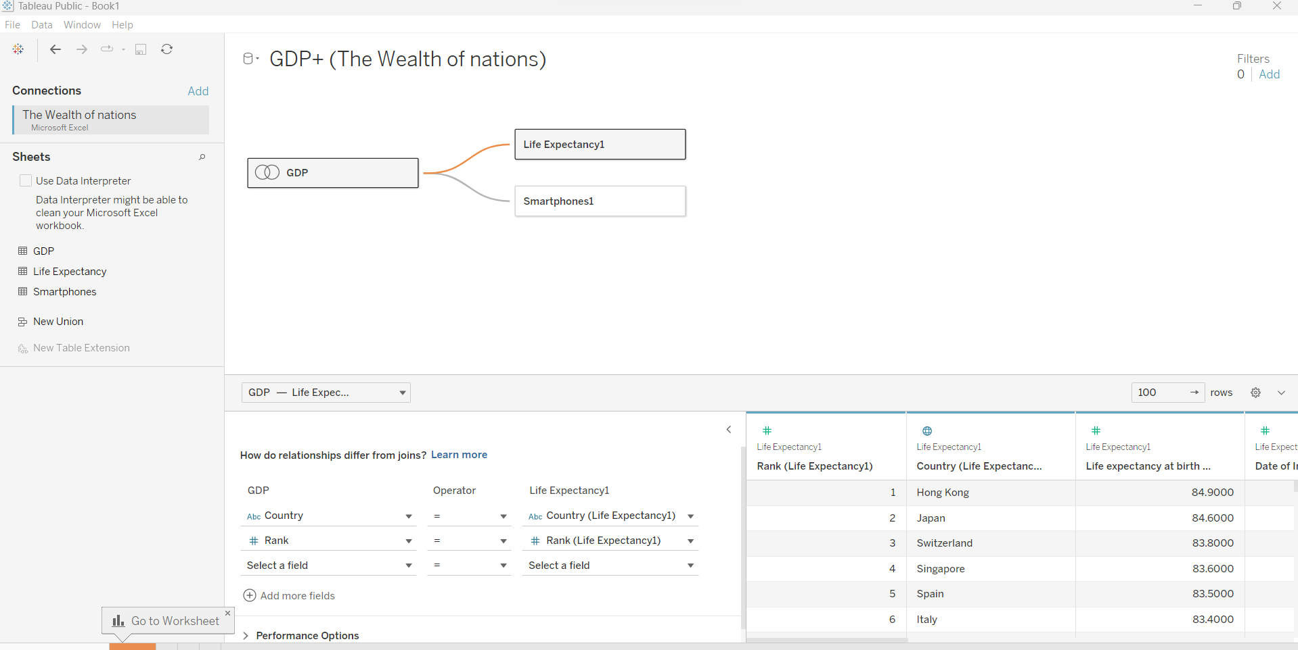**Note columns Country and Rank are set equal in the relationship.**

1. Check Data Types

Check and change the data type of afield by clicking on the arrow and hover over ‘Change Data Type’ and choose a new type of data.

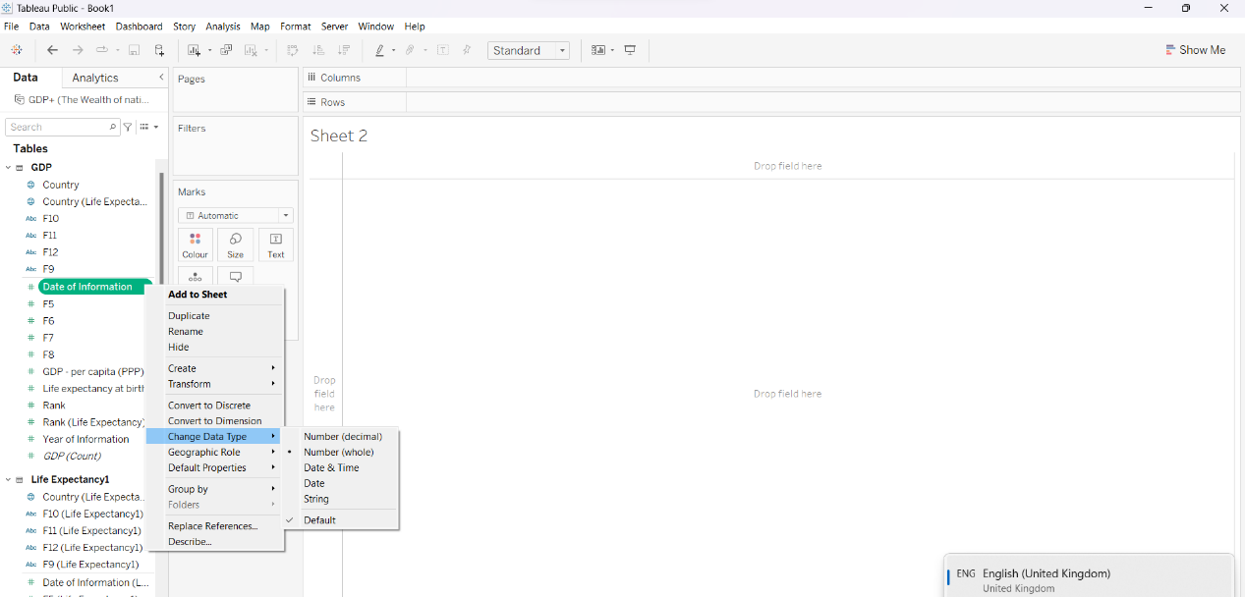

Three tables displayed on the Data panel to the left with ‘Dimensions’ on top of ‘ Measures’. Each data type is represented by a symbol and visible on the left side of the field.

1. Build Charts

**Bar Chart**

[The Wealth of nations-Top20.xlsx (sharepoint.com)](https://justit831.sharepoint.com/:x:/r/sites/SkillsBootCamp-SoftwareDeveloper21-22/_layouts/15/Doc.aspx?sourcedoc=%7B125FFB2B-03BE-42BA-936C-F5DB1A8FA0CC%7D&file=The%20Wealth%20of%20nations-Top20.xlsx&action=default&mobileredirect=true)

Our data, ‘Wealth of Nations’ is incomplete for the requested Top 20 countries and Smartphone users. A table is downloaded from World Data Bank with information about the top 20 countries with smartphone users in 2015. This data is imported from hard drive into Tableau. The relationship has been set by setting the ‘Rank’ column between the three tables containing the selected data.

The data type in ‘Rank’ is changed from number to string.

The colour palette is set to blue for grouping similarities and showing differences of the values.

This chart introduces the top 20 countries with the highest GPD per capita.

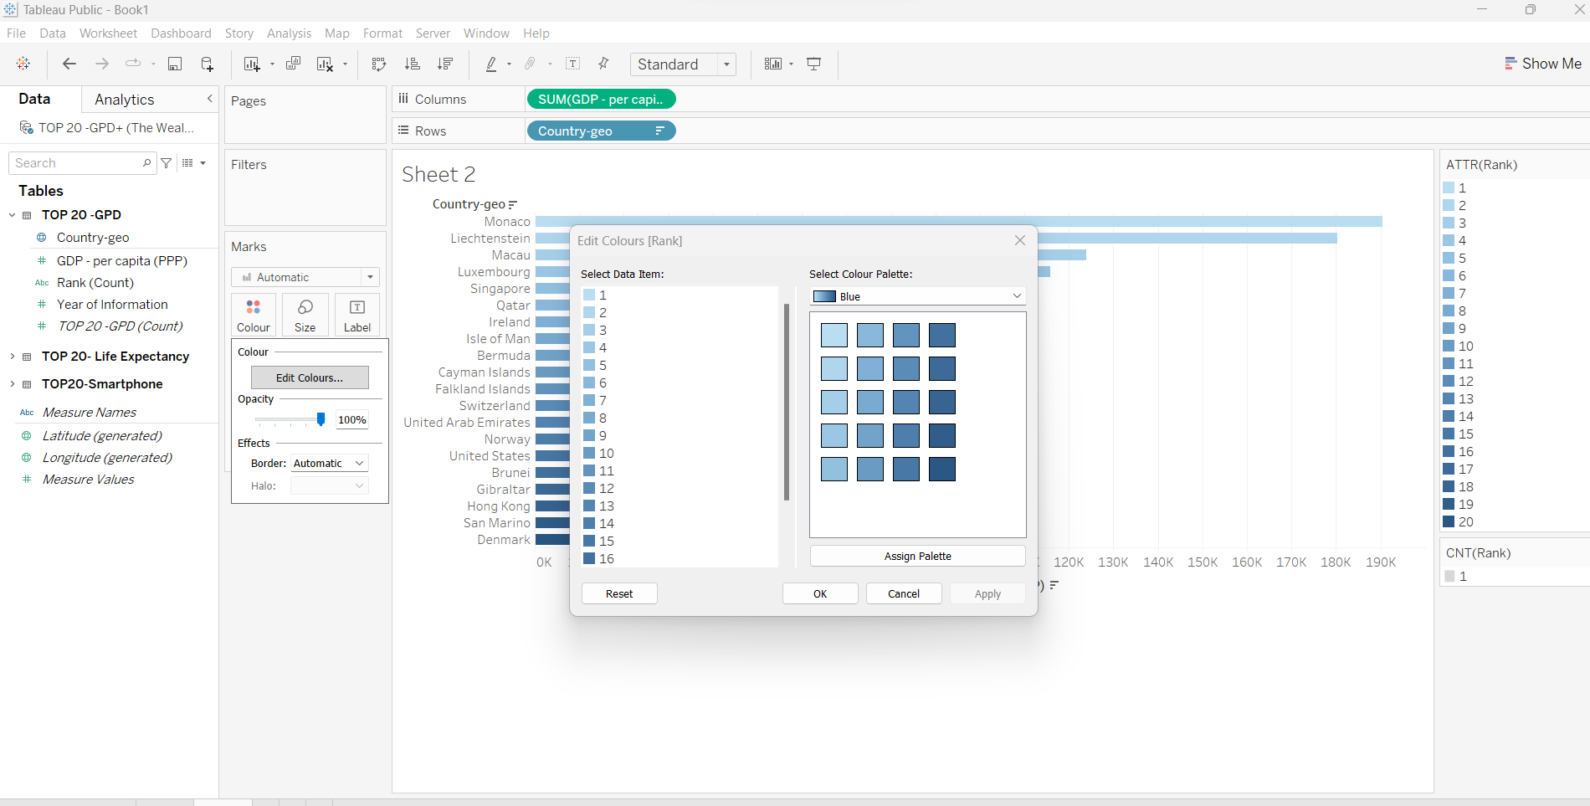**The blue colour with shades is chosen as required. Chart, axis, and legend titles are edited and formatted.**

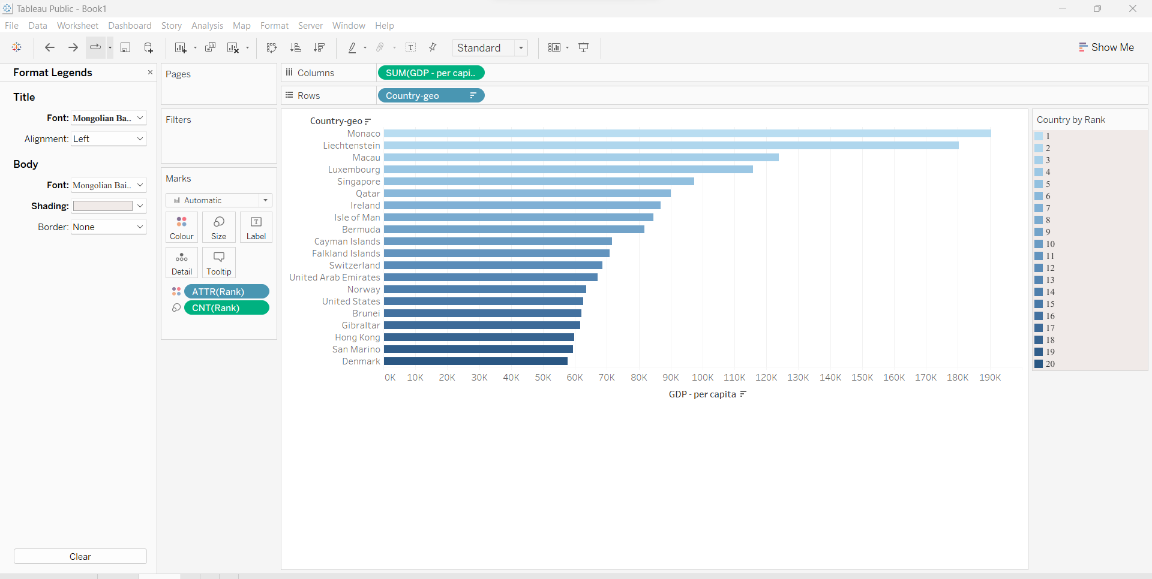**The fields used are marked in red. The fields are dropped into boxes as shown.**

**Bar and Line chart**

This double chart is created to show the relation between higher GPD per capita, life

expectancy and the number of smartphone users.

Drop ‘Country’ to columns, ‘GPD- per capita’ in rows for a bar chart. Drop ‘Life expectancy ‘ in both colour and labels in the marks card.

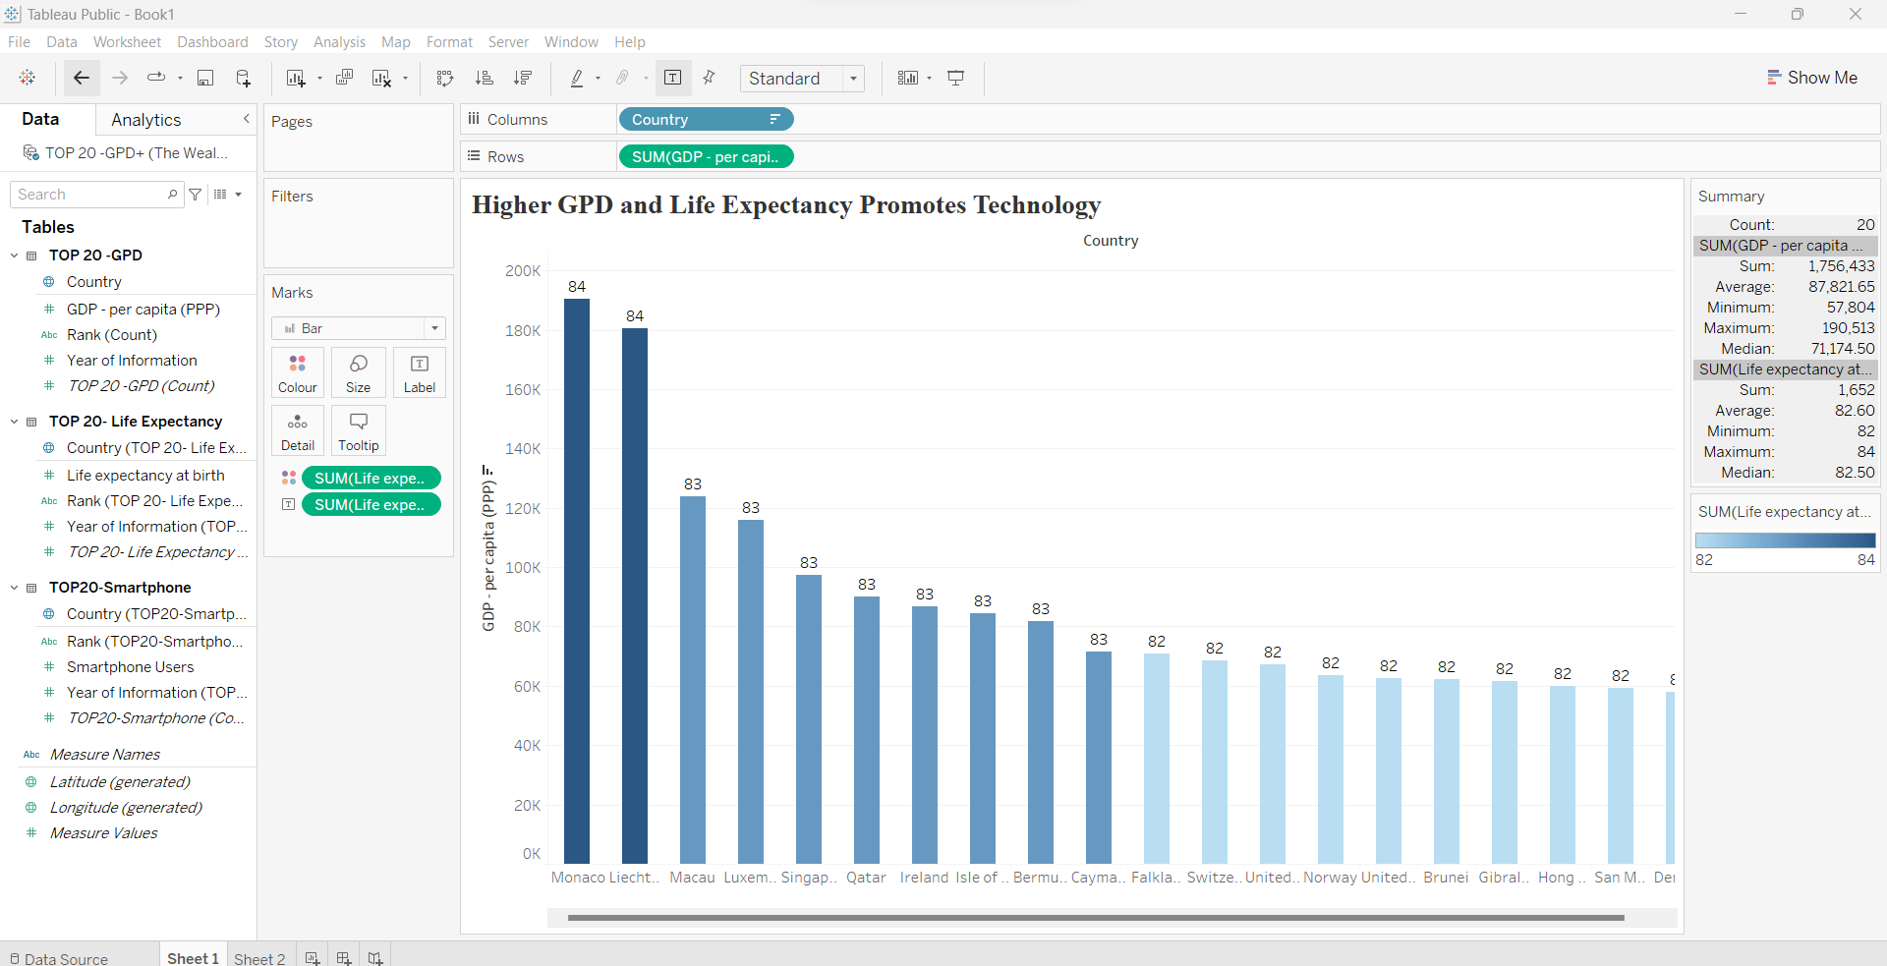**Choose Summary for the legend to display information related to a selected country.**

Then drop ‘Smartphone Users’ into rows and into the labels. Any country can be chosen for details about GPD, Life expectancy and smartphone subscriptions.

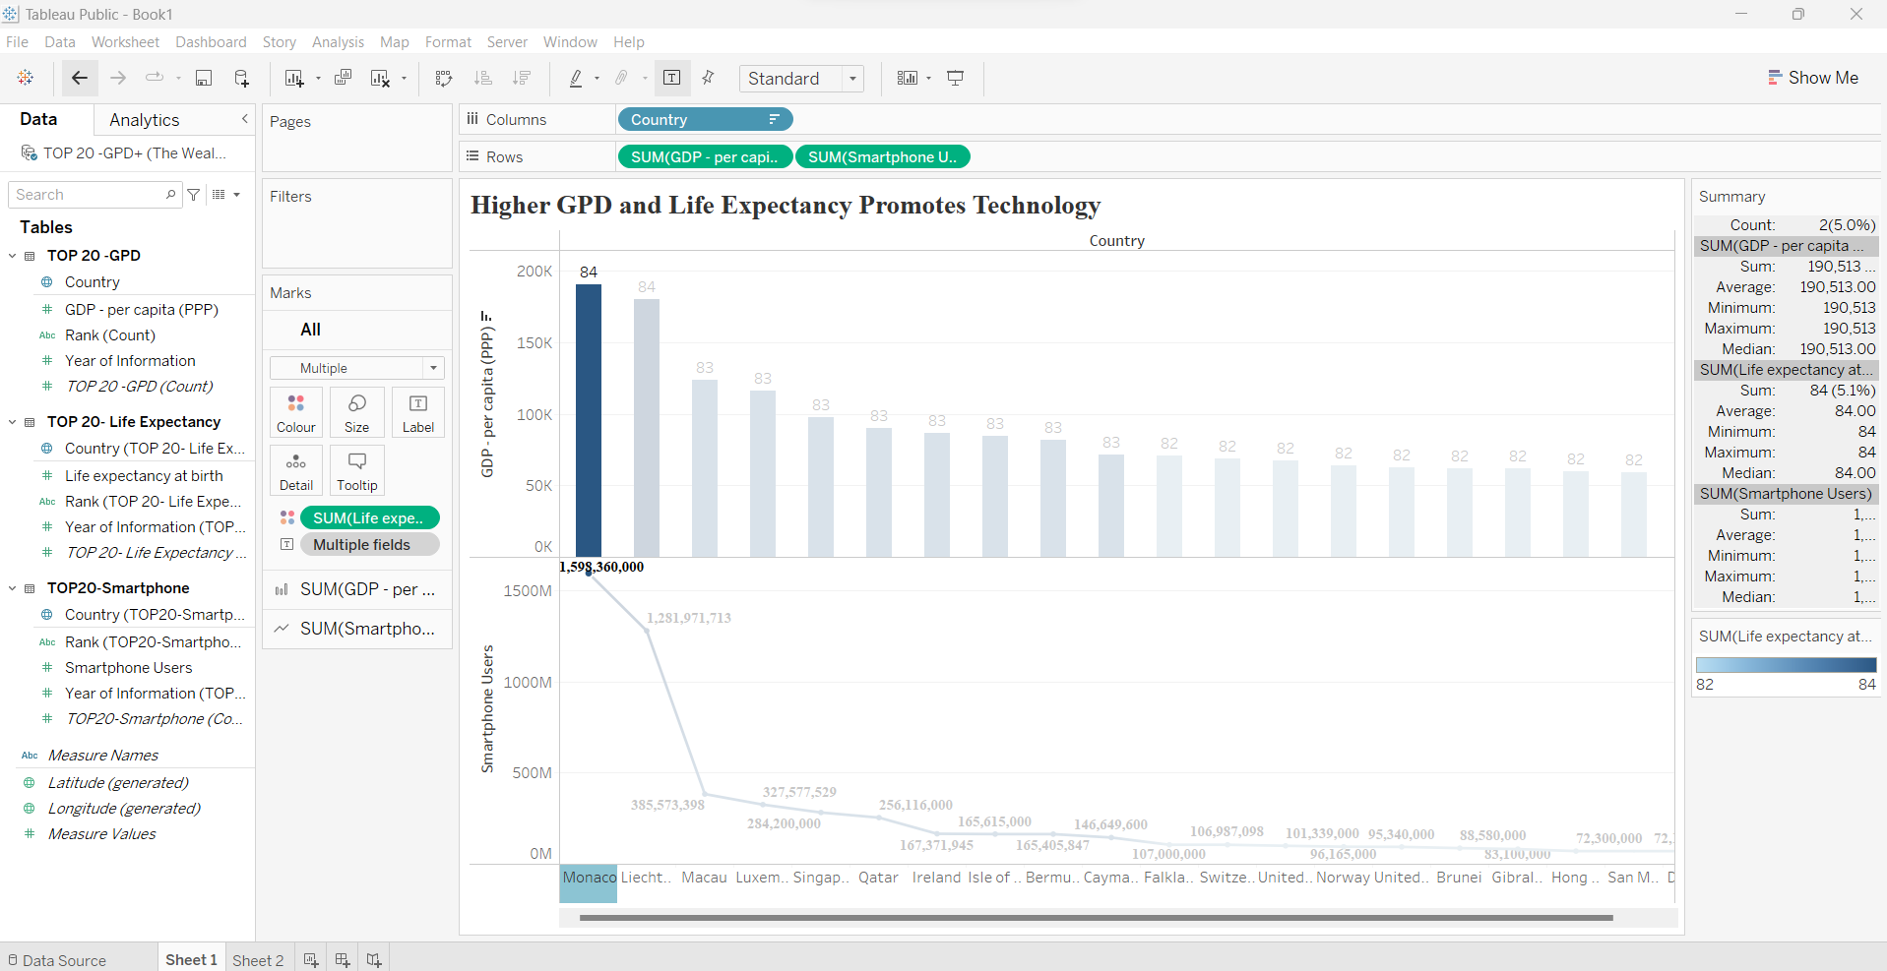

Scatter plot chart

The Smartphone subscribers displayed with increasing GPD per capita on a logarithmic x-axis for clarity for each of the countries. This chart shows the relation between the number of subscribers and GPD per capita. Three markings display a larger increase in the number of subscribers.

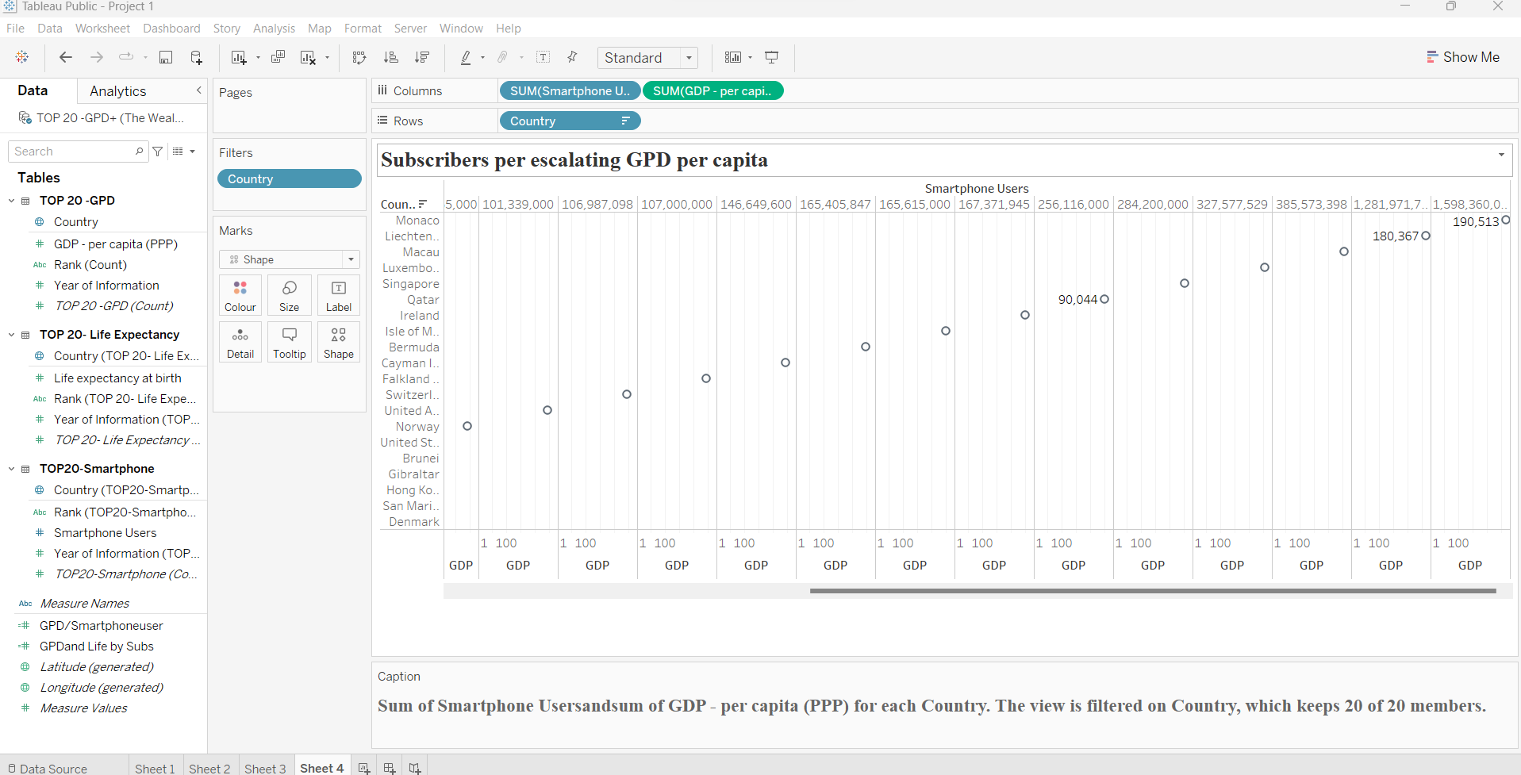**This chart is using the label card instead of the colour card.**

**The Map**

Filtered a null value.

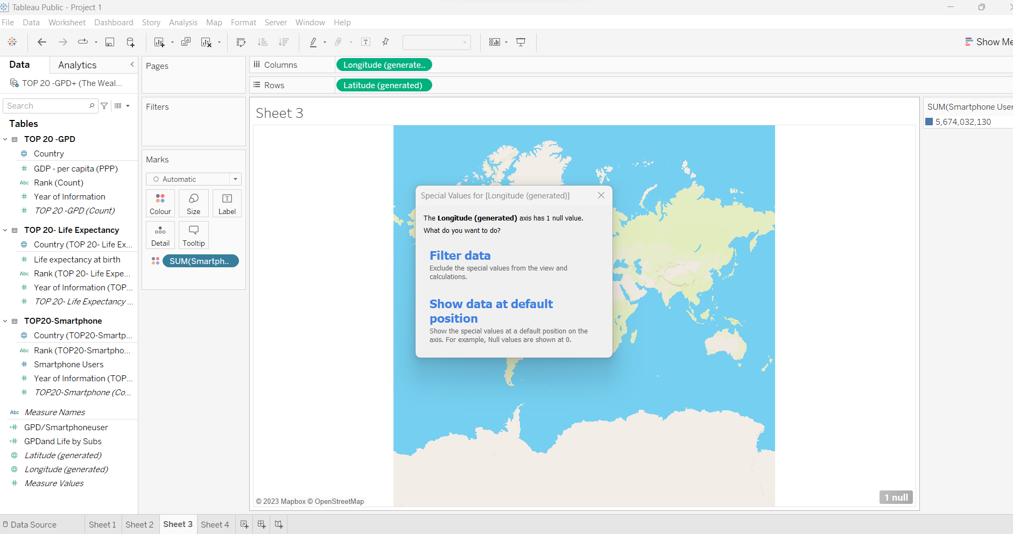

**Dashboard**

From ‘Dashboard’ on the ribbon, click on ‘New Dashboard’. Increase the width to cover the full size of the canvas.

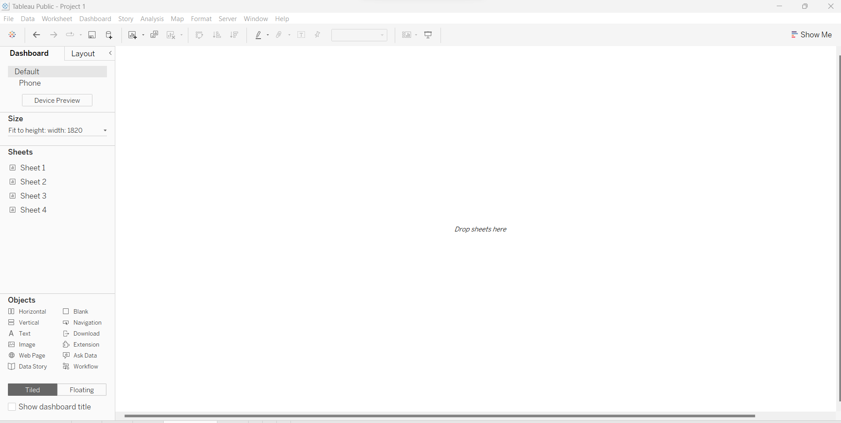C**lick on the arrow under ‘size’ marked in red to get the dropdown menu.**

The final view on the Dashboard.

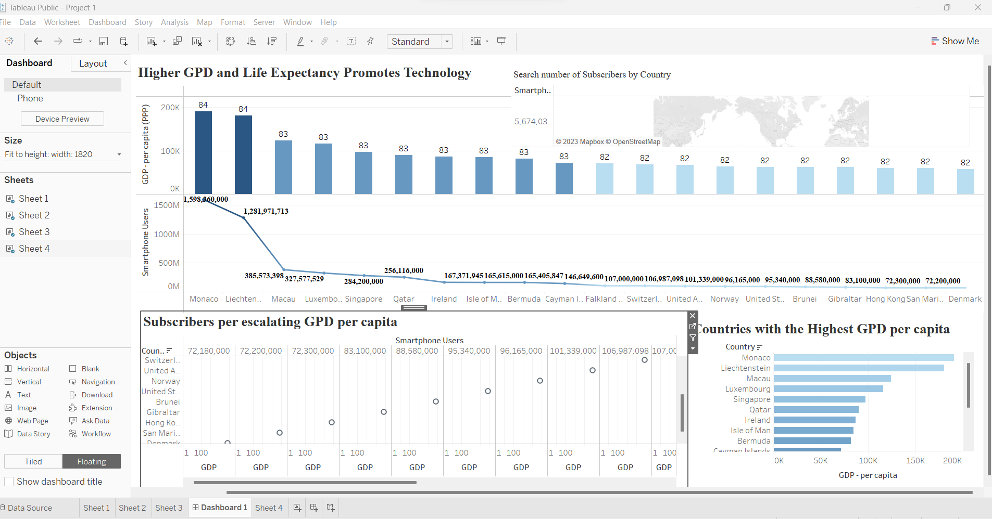

**Reflections**

The data I used is not complete. The GPD-worksheet has 228 counties, but the year of information is between 2014 and 2020. Filtering years would diminish the numerical data to single cells. ‘Life Expectancy’- worksheet has 196 countries and all information is gathered in 2020. However, life expectancy at birth with 1 decimal is not as detailed as the other data. So, it will not be useful to decide trends and relationships.

The third worksheet, ‘Smartphone Users’ has a copy of the number of users copied into the country column. I have decided to download the information about smartphone subscribers in the top 20 countries from World Bank Data. But I only managed to get a worksheet covering up to 2015 which is 5 years behind the final year of information gathering in 2020.

I made three tables over the top 20 countries, GPD per capita, Smartphone users and Life expectancy, and I set the relationship by country. Unfortunately, I still could not find a clearer relation between GPD, life expectancy and the number of subscribers.

I see that data must be processed and analysed before visualisation, so that there is sufficient data to support queries.